Extension of MSP: Fiscal and
Welfare Implications

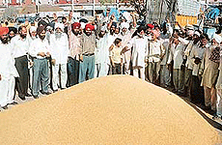
(A study for the Planning Commission)

October 2007



Acknowledgement

We are deeply grateful to Professor Abhijit Sen, Member and Professor Arvind Virmani, Senior Advisor, Planning Commission, whose valuable comments during the work in progress presentation was of great help.

We gratefully acknowledge valuable comments from Dr. Kirit Parikh Member, Planning Commission through out the course of this work. Our thanks are also due to the other staff of Planning Commission, who helped through out the course of the work. Finally, we acknowledge the help extended from other colleagues of IRADe.

Jyoti Parikh
Chandrashekhar Singh

Executive Summary
Background
The emergence of agricultural Price Policy in India was in the backdrop of food scarcity and price fluctuations provoked by drought, floods and international prices for exports and imports. This policy in general was directed towards ensuring reasonable (affordable to consumers’) food prices for consumers’ by providing food grains through Public Distribution System (PDS) and inducing adoption of the new technology for increasing yield by providing a price support mechanism through Minimum Support Price (MSP) system.

MSP is viewed as a form of market intervention by the central government and as one of the supportive measures (safety nets) to the agricultural producers. This has also a strong linkage to factor market. In this situation, two important aspects deserve attention, viz., (i) insulating the farm producers against the unwarranted fluctuations in prices, which may be provoked by among others, international price variations (ii) creation of an incentive structure for the farm producers in order to direct the allocation of resources towards desired crops and (iii) insulating consumers’ against sharp price rise, which may have been created by monsoon failure or even by vested interest by creating artificial scarcity. The focus is to create value addition for the cultivators as well as the consumers’. Therefore, it is necessary to consider some policy alternatives and view effectiveness of MSP as an instrument in this background.

Procurement of food grains at MSP is carried out by Food Corporation of India (FCI). FCI operates however, in only selected states and selected districts which had surplus of food grains initially. In the current situation several other states which have had deficit have started getting surplus. Farmers in these states are deprived of the benefit of MSP. Market prices in some mandies fall below MSP. Thus, there is a need to extend effective procurement operations in other states to ensure MSP to farmers. This has also an advantage that transport cost of operating the PDS would be reduced. In the recent past, agricultural production pattern across states has seen a change; some of the earlier deficit states have started posting surplus of food grains. Besides, it was felt that by encouraging the states to take up procurement operations, the benefits of MSP can accrue to farmers throughout the country. Under the “extended procurement regime” simulated here the designated states could locally procure, store and distribute food grains as per allotments indicated by the central government under PDS.

Issues Addressed
The present study analyze the impacts of a hypothetically extended procurement system (bringing new states and more districts of existing states under procurement net) of food grains at both macro and micro levels, for example i.e. on the level of procurement, the consequent changes in fiscal outlay, impact on local mandi price (Retail price) and consequently change in producers’ income and consumers’’ expenditure on food grains, under ceteris paribus.

Approach
In the present study district wise procurement (rice and wheat) quantity and farm harvest price along with market price are analyzed to see the likely impact of extended procurement system on the volume of procurement and local market price. Unit value (ratio of household monthly consumption expenditure on wheat and rice and their respective quantity consumed) obtained from NSS 55th (FY 1999-00) and 60th (FY 2004) round survey data is taken as proxy for the market prices of wheat and rice. We relate market price as a function of per capita production and farm harvest price. We then work out implication of extended procurement regime. In all districts harvest price will be Maximum of MSP and harvest price. Change in procurement quantity, change in market price, and consequent change in gains or loss to producers (Rice and wheat) and consumers’ are calculated under ceteris paribus. Fiscal outlay in terms of subsidy which is difference between procurement (included operational cost and transport cost) and PDS price is calculated. The analysis is done only for two states Uttar Pradesh and Madhya Pradesh for FY 1999-00 and Year 2004.

Selection of States
For the analysis two sample states were selected based on the criteria like prevalence of MSP (procurement operation should be taking place in the state but at minimal level), sound production and consumption base of rice and wheat, union territories and small states should be excluded analysis should be generalizable for the country as a whole, for which it is better to take large states as a sample), level of poverty (PDS concerned more with the poor than the rich households due to their low purchasing power) etc.

Results
It is found from the sample data analysis for UP, that the consumers’ experience a mix response. The study results show consumer aggregate expenditure on rice consumption (PDS and other source) is decreasing due to increasing proportion of subsidized PDS rice (made available to consumer) in the consumer rice mix. Aggregate consumer expenditure on wheat is increasing by a small margin due to increase in effective price of wheat. This might result in a change in consumption pattern in the favor of wheat as rice will get substituted by wheat. Extension of MSP raises income of both rice and wheat producers, due to high realized effective price (mix of market price and procurement price) by producers. In other words extension of MSP shows a clear positive gain for producers of both rice and wheat. Though producers and consumers’ are gaining marginally with this extended procurement system fiscal support required to carry out the procurement operation is increasing by 3 to 4 fold.

The substantial increase in fiscal outlay as a result of extended Procurement system can be attributed to the fact that, most of the districts in Uttar Pradesh have considerable quantities of these food grains left un-procured that can be procured by extending MSP to all districts so far uncovered. Substantial rise in fiscal outlay in percentage term compared to percentage gain posted by producers and consumers’ is on account of the benefit of the system under new arrangement which is percolating to the entire state which was limited to few districts.

In Madhya Pradesh, extension of MSP led to an increase in producers’ income for both rice and wheat. Consumers’ are also getting benefited there as their aggregate consumption expenditure for both rice and wheat are decreasing. Unlike Uttar Pradesh, in Madhya Pradesh both producers and consumers’ of both wheat and rice are experiencing positive gain. Like Uttar Pradesh fiscal support required to carry out extended procurement in Madhya Pradesh too is increasing by a substantial margin.
Concluding Remarks
Analysis of this new hypothetical extended procurement system in both the selected states for both the analysis periods are showing by and large same trend that the consumer and producer gains are increasing on the cost of substantially rising fiscal outlays. Substantial increase in fiscal support is accounted to an extensive coverage of procurement by bringing uncovered districts under procurement net. The important fact emerging from the study is that the fiscal support extended to carry out extended procurement is translating into a gain to a large section of poor farmers. Government subsidy which is benefiting only small pockets of farmers residing in the areas covered under procurement operation to the farmers through out the state. Since this is a sample based analysis and the percentage changes are calculated based on the reference period figures. It is still an open ended question by this analysis that whether the rise in fiscal burden is compensated by the aggregate gain to the societies or not. Rice and wheat figures prominently in the food grain basket of the people. One would therefore expect that the gain to people, particularly the poor ones, would offset the impact of higher fiscal outlay. Efforts are needed to achieve lower consumer prices, greater food consumption, and sufficient grain stocks to meet any unforeseen contingencies in future.
.
.

Table of Contents
Acknowledgement ii
Executive Summary iii
Table of Contents vii
Chapter 1 1
Introduction 1
1.1 Background 1
1.2 Role of FCI (Food Corporation of India) 2
1.3 Minimum Support Price: An Overview 3
1.3.1 Minimum Support Price and its Supply Response 3
1.3.2 Minimum Support Prices & gains/loss to producer and consumer 8
1.4 Extension of MSP & Fiscal Deficit 10
1.5 Similar Studies: 14
1.6 Objectives 15
1.7 Methodology for current study 16
Chapter 2 17
Agricultural production and procurement - All India Analysis for Selection of States 17
2.1 Selection of States 17
2.1.1 Indicators Considered 17
2.2. Identification of States 18
2.2.1 Procurement of Rice and Wheat 18
2.3.1 Rice Production: 19
2.3.2 Wheat Production: 20
2.4 Consumption Pattern of Rice and Wheat across Different States: 21
2.5 Surplus/ Deficit Status of Rice and Wheat across the States: 22
2.6 Implementation of Minimum Support Price (MSP) 24
2.7 Level of poverty 24
2.8 States which can be selected 25
Chapter 3 27
CASE STUDY 27
3.1 Agriculture Scenario – Baseline Information 27
3.1.1 Uttar Pradesh 27
3.1.2 Madhya Pradesh 28
3.2 Data Analyzed 29
3.2.1 NSSO 55th Round Uttar Pradesh 29
3.2.2 NSSO 55th Round Madhya Pradesh 31
3.2.3 NSSO 60th Round Uttar Pradesh 31
3.2.4 NSSO 60th Round Madhya Pradesh 32
Chapter 4 33
Methodology and Analysis 33
4.1 Data used for the analysis 33
4.1.2 District level Harvest Price (HP) 34
4.1.3 District level Procurement (Q) 34
4.1.4 District level per capita consumption 34
4.1.5 District level production 35
4.2 The model framework 35
4.2.1 New market price (MP*) with extended procurement system 35
4.2.2 Procurement (Q_{p}*) with extended procurement system 38
4.2.3 Change in producers’ income 39
4.2.4 Change in consumers’’ expenditure 39
4.3 Change in fiscal outlay 40
Chapter 5 42
Findings of the study 42
5.1 Regression Results 42
Chapter 6 48
Conclusion and Recommendations 48
References 52
Annexure 55

Chapter 1

Introduction

1.1 Background
The agricultural pricing policies and allied institutional mechanisms evolved in India in the context of shortages in the availability and excess demand for food grains during 1960s (Kahlon, 1983). A system of procurement and distribution of major food grains was introduced and statutory minimum prices were set, though not strictly enforced. India’s agricultural price policy includes three main types of administered prices: support, procurement, and issue price. The support price is generally announced at sowing time, and the government agrees to buy all grain offered for sale at this price. These prices guarantee to the farmer that, in the event of excessive production leading to over supply in the market, prices of his produce will not fall below the support price. Support prices generally affect farmers’ decisions indirectly, regarding land allocation to crops. The areas to be sown, however, depend upon the actual prices farmers realized for the previous crop and their expectations for the coming season.
The quantity to be procured is determined by the government’s needs for disbursements under the public distribution system. In recent years, however, the actual quantities procured have depended upon the grain offered for sale by farmers at prices fixed by the government. These prices are generally higher than the support prices but lower than the free market prices in normal years. In a good crop year, in surplus states, free market prices would have been lower but for government purchases; after the surplus is mopped up, market prices tend to run higher than procurement prices. The government recognizes the importance of assuring reasonable prices to farmers to motivate them to adopt improved technology and to promote investment by them in farm enterprises for increasing agricultural production. The basic objective of agricultural pricing policy in India is to evolve a balanced and stable price structure to meet the overall needs of the economy while protecting, in particular, the interests of the producers’ and the consumers’’. The policy is aimed towards facilitating the desirable path of attaining the objectives of growth and equity in the process of economic development.
Incentive prices in the form of minimum support prices are essential to the success of agricultural production programs based on high-yielding-varieties technology. At the same time, undue reliance cannot be placed on environment of high prices alone as an incentive for increasing production of food grains. Effective implementation of price support policies requires adequate institutional arrangements for the purchase of quantities offered for sale at that price.

1.2 Role of FCI (Food Corporation of India)

The broad objective of food policy in India has been to make food available to the people at reasonable prices. Specific objectives include providing remunerative prices to cultivators; supplying food at subsidized prices to the undernourished; controlling inflationary pressures; stabilizing prices for consumers’ and producers; reducing fluctuations in food availability and achieving self sufficiency in food grains production.
On behalf of the Central Government, Food Corporation of India (FCI) along with State Governments and their agencies procure a sizeable quantity, of the total grain that is harvested in a season. Since production is concentrated in a few states of India, there is a large regional mismatch between supply and demand of food grains, which is relieved by the transfer of grains from surplus to deficit states.
In order to facilitate the farmers to bring their produce to the procuring agencies, purchase Centers (Mandies) are supposed to be opened in all corners of the country. However procurement of wheat and rice are usually being done in selected states only. The FCI/ Government Agencies purchase all the grains offered at the minimum support price (MSP). The main areas for procurement of wheat and rice are the surplus states like Punjab, Haryana, and some parts of Uttar Pradesh for both crops and Andhra Pradesh for rice.
The Food Corporation of India (FCI) was set up under the Food Corporations Act of 1964 to be the nodal central government agency responsible for the purchase, storage, inter- state movement, transport, distribution and sale of food grain and other food items. In short, the FCI is responsible for implementing central government policies on procurement, storage, and distribution. In certain operations such as the maintenance of national buffer stocks, the FCI has sole responsibility whereas in certain other operations such as procurement, the FCI has to work with State government organizations (such as State marketing federations) and within the purview of State government policies.

The role of the Food Corporation of India (FCI) has evolved over time, from being an agency to procure food grains and distribute to states for the operation of the public distribution system (PDS), in recent years it has become a device of maintaining the Minimum Support Prices by procuring whatever is offered. FCI’s procurement operations are concentrated in only a few states. This has led to problems of two kinds, one, growing buffer stock with FCI as the MSPs have been set above the market clearing price. In the year 2001 buffer stock accumulated in FCI’s go-down had toughed to the historical high. There was a huge debate going at that time among policy maker’s academician and planners about the proper utilization of this buffer stock. Irony of the situation was that our go-down was reporting overflowing stocks of food grains, but, at the same time some parts of the country reported death due to starvation. This shows inefficiency of distribution system in delivering food grains to needy. This buffer stock situation continues till recent past. But now the situation has changed rather than having over flowing buffer stocks countries has resorted to import of food grains. Second farmers of those states where FCI price support operations are not well organized do not fully get the benefit of the support price.

1.3 Minimum Support Price: An Overview

1.3.1 Minimum Support Price and its Supply Response
Even prior to mid sixties, it was recognized that for the acceleration of agricultural growth, farmers need to be motivated to adopt better technology and to invest more in their farm enterprises. This evidently was difficult without assuring reasonable prices to the farmers. The Government constituted a committee to suggest price policy for food grains for the 1964-65 and to suggest the terms of references for an organization which would be set up to advice the government on price policy on a long term basis. The recommendations of the committee led to the establishment of the Agricultural Price Commission in 1965 which was later renamed as Commission for Agricultural Costs and Prices (CACP) in March 1985. Simultaneously, the development strategy for agricultural sector was also remodeled. Remodeling of strategy included application of modern inputs like high yielding varieties of seed (HYV), chemical fertilizers and mechanization of certain agricultural operations. Thus, main emphasis in this development was on finding methods of increasing land productivity through the use of modern input and improved methods of production in the potential regions of the country. This development strategy in turn required that price policy should encourage farmers to make greater investments in farm operations so as to enable them to shift on to higher production possibility curves. Thus the minimum support price was aimed to:
- Assure remunerative and relatively stable price environment for the farmers by inducing them to increase production and thereby augment the availability of food grains.
- Improve economic access of food to people.
- Evolve a production pattern which is in line with overall needs of the economy.

Therefore, the provision of Minimum Support Prices (MSP) was initiated during the mid-1960s to create a favorable environment for the producers of major food crops, which were seen to possess vast potential for raising grain production. Presently, 24 major crops are covered under the minimum support price program (paddy rice, wheat, five coarse grains, four pulses, eight oilseeds, cotton, jute, tobacco and sugar cane). With the price support policy favoring food grains, there is very little incentive for the farmer to move away from the food grains to the production of other crop. The price support policy has been a major deterrent to crop diversification. In determining minimum support prices, the CACP has taken into account cost of production as well as domestic and global market conditions. MSP is determined by the principle of full cost of production that includes the rental value of land, an imputed value of family labor and returns to management (indiabudget.nic.in).
This policy has proved to be helpful in several ways. From a situation of massive shortages, India has emerged as a grain surplus country with self reliance in food grains, and this inherent process of self sufficiency subsumed the in built proposition of attaining food security at the national level. A strong base has been created for grain production and for meeting grain demand in the medium term (Tyagi.1990, Acharya, 1999; Connell, Hirad and Jahan, 2004). The policy has had a favorable impact on farm income and has led to an economic transformation in the well-endowed, mainly irrigated regions. The other purpose of MSP was to maintain price stability in the food grain market.
However, the adverse effects can also be recognized as the food policy has been highly asymmetric and skewed mainly towards the production of rice and wheat at the cost of cultivation of pulses, oilseeds and other crops. This has created serious imbalances in demand and supply of principal crops in the country. Similarly, the country has been facing large shortages of pulses and edible oils and now has to meet about one-tenth of its demand for pulses and close to half of the demand for edible oil from imports. These imports are in turn having an adverse impact on producers in the unfavorable dry-land areas These changes necessitate a fresh look at the role and relevance of the Minimum Support Price system in the country.
The implementation of Minimum Support Prices (MSP) in the high potential regions of the country has played an important role in meeting the ultimate goal of improving the agricultural production and the welfare of the agricultural community. A study Conducted by Deshpande and Naika (2002), examine the impact of MSP on agricultural growth by analyzing its relevance and effectiveness in certain crops. This study indicates that wheat and rice got the best out of price policy through MSP but unintentionally this worked as an externality to discourage coarse cereal and pulses. Therefore, the policy is biased against certain crops which are grown in agriculturally backward regions and mostly by resource poor farmers. There are certain factors influencing the effectiveness of MSP e.g. the manner of implementation of the policy, undue dependence on the state for intervention lack of required information at appropriate time etc. It was also experienced that there are a number of institutions involved in procurement process and there is inadequate coordination between them.
Another study by Karwasra, Kundu and Jain (2003) observed the impact of domestic price policy on the production of rice and wheat. The study supported the fact that the MSP for wheat and rice, which have been maintained reasonably high, has helped the farmers to increase their production. Similarly, Sidhu and Singh (2003) also found that the provision of MSP for wheat and paddy encouraged the farmers to produce the grains as marketable surplus.
The strategic objectives of agricultural development in India have been changing over time. During the period up to mid sixties, the basic objective was to maintain the prices of food grains at low level; in the mid-sixties to early eighties the objectivity was to maximize food production. In the early eighties to early nineties the objectives changed to go for a demand driven production pattern. Since early nineties, the strategic objective was to reduce inputs of agricultural commodities. When India’s import of cereals had reached an alarming stage during the mid of sixties, a new strategy of agricultural development was launched in the country. The strategy included technological package, provision of input delivery and assured remunerative prices for agricultural production. Under this strategy of agricultural development, various institutional instruments were used. These include fixation and announcement of minimum support prices for the selected commodities, provision of marketing facilities, efficient marketing regulations and provision of Public Distribution System (PDS) of certain commodities like wheat and rice at subsidized price to poor households in the country (Acharya, 1999).
The dynamic role of policy prescriptions for agriculture in a country like India has been widely acknowledged. During eighties the import of cereal had come down negligible level. The share of rice and wheat production had increased as much as 94 % while the share of coarse cereal had come down drastically i.e. from 43 % to 18 %. It is found that production of the cereals was more dispersed across the regions. The growth of production of rice was more dispersed as compared to that of wheat. The concentration of production in case of wheat was also limited to certain states like Punjab, Haryana and Uttar Pradesh (Acharya, 1999).
Singh, Rangi and Kalra (2004) concluded that productivity of wheat in Punjab increased by more than 5 times in five decades (1950 to 2000), area by three times and production by more than 15 times. The increase in MSP during a period of more than two decades, 1977-78 to 2000, was more than five times. The minimum support price policy played a crucial role in bringing India out from deficit to surplus position in food grains. However, the experience suggests that price intervention distorted output crop-mix. During the decade, area under wheat had increased by 0.53 million ha. in Haryana, Punjab and Uttar Pradesh. The area under paddy in Punjab increased from 2 million to 2.6 million hectares, presumably in response to high procurement price (Chand, 2003; Word Bank, 2003)
There were six and four states for rice and wheat respectively where MSP was implemented (Table1.1). Besides, it emerged (Acharya, 2001) that there were also state procurement agencies contributing their share in the procurement stock of both rice and wheat.

Table.1.1: Major states Procuring Rice and Wheat
Rice | Wheat
West Bengal | Punjab
Tamil Nadu | Haryana
Orissa | Uttar Pradesh
Madhya Pradesh | Rajasthan
Karnataka | Madhya Pradesh
Source: www.agricoop.nic.in
Out of the incremental marketed surplus of rice and wheat, share of other agencies including private traders has been considerably more than that of public agencies (FCI and state procurement agencies). Because of the limited presence of public agencies and implementation of MSP, the farmers who had marketable surplus do not fully benefit from the MSP regime.
Similarly, Chand (2006) also noted that MSPs have been very effectively implemented for some crops and in some regions through procurement of produce by official agencies. These include procurement of paddy and wheat by FCI and other official agencies in the states/ regions like Punjab, Haryana, Western Uttar Pradesh and Tamil Nadu, which were early adopters of green revolution and offer sizeable marketed surplus.
In most of the surplus producing regions, the state Governments and their agencies remain active for implementation of the policy of adopting minimum support prices. Areas where, the need for price support arises only once in two or three years, the public agencies were not able to provide effective support to the farmers when the price falls below MSP as they couldn’t tie up with central nodal agencies for making necessary purchase arrangement in time. Such failures on the part of states lead to a setback to the production programs. Most of the upcoming cereal producing state like eastern Uttar Pradesh, Madhya Pradesh, West Bengal, Orissa, Bihar and parts of some states are likely to experience this frequently. These are the areas where there is considerable scope for increasing the yield. It is in this context that for accelerating the production of food grains not only the market infrastructure needs to be strengthened but the price support policy needs to be effectively implemented in all the regions of the country (Acharya 1998; 2001).

1.3.2 Minimum Support Prices & gains/loss to producer and consumer
The procurement of rice and wheat is also undertaken to maintain a buffer stock for dealing with price fluctuations and maintaining an operational stock for the public distribution system. While wheat is directly procured by FCI and other state agencies, part of rice is procured through the system of levy, under which rice millers are required to provide a certain percent of rice from the paddy purchased by them to the government agencies at a levy price derived from MSP. The state maintains a buffer stock of rice and wheat as a safeguard against the adverse impact of fluctuations in price and production of agricultural produce. These interventions have served the purpose of improving food security, maintaining price stability and the creation of favorable pricing environment. However, these interventions have also come under severe criticism. In this regard, some scholars have raised certain issues in their studies.
The provision of minimum support prices was found to have served only a small number of crops in a particular region; most of the crops and states could not benefit from them (Chand, 2003). It was also noted that the price policy favored the selected crops that resulted in substantial decrease in area and production of some coarse cereal, which were preferred by poor across the region. Deshpande and Naika (2002) found in their micro level verifications that that MSP does not bear any consistent and significant relationship with either the wholesale price or farm harvest price. Cropping pattern is largely influenced by market price and MSP plays a role only when MSP is either equal or above the market price. The study also observed that a hike in MSP ignored the demand-side factors that caused adverse impacts on food security for poor (Chand, 2003). Similarly, through the FCI’s procurement, distribution and buffer stocking program Government of India repressed private food grain marketing, hindering their potential contribution to long term food security (World Bank, 1999).
Jha and Srinivasan (2006) studied the welfare effects of procurement prices of rice and wheat across the states using model simulation. Welfare implications of alternative scenarios, defined as decentralized PDS/Procurement policies (State agencies will carry out procurement at the going market price which is assumed to be higher than MSP price) policies and centralized PDS/Procurement policies (FCI will procure on behalf of central government at MSP announced by government) are obtained. Further two more scenarios are constructed by assuming a gradual reduction of 10% and 20% in MSP. Domestic trade of grains restrictions are not accounted in the simulation. Changes in consumption are calculated by assuming constant price elasticity.
It was found that a switch from a centralized procurement system to a decentralized procurement system leads to a reduction in rice consumption by a slight margin in states that face high market prices, but the rise in consumption in other states (having low market price) outweighs the decline in consumption of all states put together. In case of wheat, the changes in consumption are negligible as market price remains unchanged. Further, it was estimated that in addition to procurement, the reduction in MSP by 10 % or 20 % results in to fall of market price at the national level by 11 % and 16 % in case of rice and wheat respectively. This causes an increase in consumption of 10.7 million tones of rice and 6.7 million tones of wheat but reduces the production by 0.62 and 1 million tones for rice and wheat respectively. Therefore, they find that if MSP is reduced, it is no longer attractive to the producers of rice and wheat to sell their produce to the procurement agencies.
In recent years, it was found that increase in minimum support price caused an adverse impact on welfare of the consumer. Parikh, Kumar and Dharbha (2003) conducted a study to examine the welfare impact of minimum support price (MSP) of wheat and rice. In their study, which simulated with a general equilibrium model it was found that when prices of rice and wheat are raised by 10%, the production of these cereals increase by 1.6 % and 2.6 % respectively, in the year immediately following the price hike. This hike could not be sustained because of fall in agricultural investments and addition to consequent fall in irrigation area. The hike in procurement prices caused an increase in both producers as well as consumer prices. This in turn, led to a significant decline in total private consumption of these two commodities by around 3% to 3.5 %. Indeed self consumption of both commodities was higher while the ration and the market consumption were lower in response to increase in prices. The increase in output along with a decline in consumption resulted in a built up of stock of these two commodities. The effects of increase in prices of rice and wheat on output, consumption and stock of other agricultural commodities were quantitatively marginal. Increase in MSP resulted in welfare loss.
Acharya (2000) observed that the percentage share of average per capita income required to buy a quintal of wheat, rice and course cereal went down substantially during two decades as the rate of increase in prices of rice and wheat has been lower than that of the rate of increase in average per capita income. Prices of rice, wheat and coarse cereal in real terms have been declining during the last two decades. As consequences of improved availability of rice, wheat and coarse cereals at declining real prices, the farmers in several regions diverted their resources from less profitable crops to other more profitable commercial crops. Deshpande and Naika (2002) found that for the farmers this practice of resource transfer is confined to the regions which are not predominantly succumb to commercial crops only. Similarly, Reddy and Reddy (2003) also note that MSP primarily covers major crops especially wheat and rice. In case of some other crops MSP failed to cover up the cost of cultivation, harming the interest of the farmers further along with regional imbalances and disparities in the policy persuasion, its implementation and coverage of commodities under MSP. Thus, the MSP scheme can have a significant impact on responsible the cropping pattern.

1.4 Extension of MSP & Fiscal Burden

As already mentioned, the Food Corporation of India along with the State Governments and their agencies procure a sizeable quantity of the total grain that is harvested in a season on behalf of the Central Government. Since production is concentrated in a few states, there is a large regional imbalance between supply and demand of food grains, which necessitates movement of grains from surplus to deficit states.
However, agricultural production has undergone significant changes in the past few years. Surpluses of several agricultural commodities have started appearing in several states and this trend is expected to continue in the coming years as well. Former deficit states like Bihar, Assam and Eastern up have started generating surpluses of certain cereals. Besides there are also pockets of surplus emerging in states which otherwise have an overall deficit. (Planning Commission, 2001).
Table1. 2: State Governments undertaking decentralized procurement scheme.
No | Name of the State | Procurement of items
1 | West Bengal | Rice
2 | Uttar Pradesh | Rice/Wheat
3 | Madhya Pradesh | Wheat
4 | Chhattisgarh | Rice/Wheat
5 | Uttaranchal | Rice/Wheat
6 | Andaman & Nicobar Islands | Rice
7 | Orissa | Rice
8 | Tamil Nadu | Rice
9 | Gujarat | Wheat
10 | Karnataka | Rice
11 | Kerala | Rice
Source: www.agricoop.nic.in
The emergence of these new surplus states and the issue of growing fiscal outlay necessitated the introduction of extended procurement scheme of the Government of India. It has been noted by several committees, e.g., GOI (1991, 2002), that the operations of FCI tended to become costly due to certain inefficiencies (e.g. transport, administrative). The proposal of extended procurement is mainly aimed at providing a greater role for state governments and private traders enhancing efficiency gains. This scheme proposed that transport and handling costs can be reduced and a more decentralized and distributed support for MSP can be provided to farmers in all states. Accordingly the trend in the food subsidies which showed an annual increase of above 27 per cent during each of the three years namely 2000-01, 2001-02 and 2002-03., came down to 4.1 per cent during 2003-04 and is expected to further decelerate to 2.54 per cent in 2004-05. It would be interesting to analyze how much of this deceleration could be attributed to the schemes.

Figure1.1: Growth of Food Subsidies
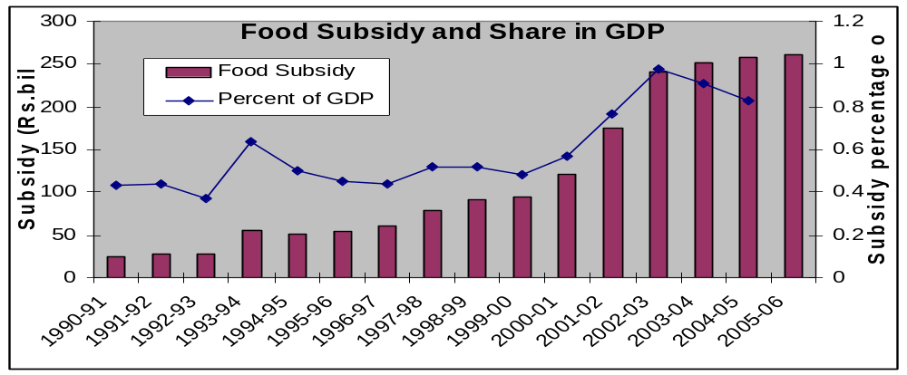
Source: Budget documents various issues and CSO
Note: 1999-00 onwards subsidy does not include sugar. 2004-05 figure is RE and 2005-06 figure is BE.
It was felt that by encouraging the states to take up procurement operations the benefits of MSP can accrue to farmers throughout the country. Under “extended procurement” scheme the designated states will locally procure, store and distribute food grains as per allotments indicated by the central government under PDS. The GOI will compensate the states for the difference between the economic cost of procurement and Central Issue Price (CIP) in the form of a subsidy. The states however cannot claim any arbitrary amount as economic cost. It would be fixed by the centre based on some norms. This has a built in incentive for individual states to be efficient. In effect the states purchase grains for the PDS at market price. In the surplus states this market price is, however, likely to be at the level of MSP. This policy allows private trade to play a greater role in agriculture marketing.
The extension of procurement scheme of the Government of India was introduced in 1997 to broaden the production base and hence food grains distribution with more effective and spontaneous participation of local people thus by encouraging the states to acquire the ability of procurement operations. Following this concept in practice, the resultant benefits of MSP could accrue to the farmers throughout the country. Under “extended procurement” scheme the designated states will locally procure, store and distribute food grains as per allotments indicated by the central government under PDS (S. Jha and P.V. Srinivasan, 2006).
The compensation in the form of subsidy will be provided by the central government to the states for the economic cost of procurement, i.e. difference between procurement price and Central Issue Price CIP (price at which grain is sold through PDS) in the form of a subsidy. The states however cannot claim any arbitrary amount as economic cost that would be fixed by the centre based on certain defined norms ensuring efficiency on the part of states. In effect the states purchase grains for the PDS at market price. In the surplus states this market price is, however, likely to be at the level of MSP, the support price. This policy allows private trade a greater role in agriculture marketing.
Recognizing the variation in prices from village to village that are captured through Mandi prices, we propose to analyze and will estimate the impact of the state level procurement at village level prices and household consumption and calorie intake of the poor. The study is carried out for the two states using NSS 55th round data.
If the states are empowered to procure food grains in their own state at the MSP and the Centre promises to reimburse them for it. Transport and handling costs can be reduced and a more decentralized and distributed support for MSP can be provided to farmers in all states. It can, however, create a number of problems. Firstly, it may be difficult to verify what the states actually do. Secondly, it may lead to much higher procurement in the aggregate imposing a larger fiscal outlay and larger political pressure to increase MSPs even more. Thirdly, once a state starts procuring at MSP in all its Mandies, we can expect that the prices of cereals may increase for many rural and urban consumers’ having a profound impact on consumer expenditure on food grains and its distribution. Thus it appears that if not handled adequately, the policy may not only lead to a staggering rise in subsidy burden but may even lead to increase in prices that can hurt poor people in rural and urban area . This study will highlight the problems by case studies of two states.

The extended system of procurement is expected to help cover more farmers under the MSP program of the Central Government and economize transport and administrative costs involved in procurement and distribution operations. Further, it helps in minimizing the dependence of State Governments on the FCI for PDS requirements and reducing the complaints about quality, as consuming States themselves are the custodians of the procured food grains.
However, the scheme has evoked limited response from the State Governments. Out of the State Agencies’ share of nearly 58 percent of total rice and 80 percent of total wheat procured by the FCI, only 33 percent rice and 13 percent wheat are contributed by the States with decentralized procurement. At present, the State Governments of West Bengal, Madhya Pradesh, Uttar Pradesh, Chhattisgarh, Uttaranchal and Tamilnadu are implementing this scheme in a limited way. The States of Assam and Nagaland and the Union Territory of Andaman & Nicobar Islands have also evinced interest in the scheme.
The concerns of the State Governments broadly relate to financing of operations (RBI valuation norms for stocks of food grains) and reimbursement of expenses and release of subsidy by the Central Government. The concerns relating to the reimbursement of expenses and release of subsidy have been largely addressed through a process of consultation of all the stakeholders concerned.

1.5 Similar Studies:
No research study has been carried out that relates to the proposed study namely, what happens if the MSP is extended to more states. However, a related paper is there by Deaton, Parikh and Subramanian (1994). They have analyzed food demand pattern and pricing policy in Maharashtra using household level survey data (NSSO 38th round) to see the variation of prices across villages, districts and households. Deaton et al (1988) studied the quality, quantity and spatial variation of prices. Subramanian et al (1991) studied the gender effects in Indian consumption patterns.
A recent study by Jha and Srinivasan (2006) analyzed some of the recent reforms proposed in the operation of government buffer stocks and provision of price support to wheat and rice farmers in India. Based on the Indian grain market scenario and the recent policy initiatives this study estimates the potential impacts of reforms in India’s farm support policies on producers, consumers’ and traders in various regions of the country. The results are based on a multi-commodity partial equilibrium simulation model of regional supplies and demands of grains by different economic classes. In particular, the study focuses on the extension of procurement of grains by the individual states. The results show that a switch to decentralized PDS and procurement and removal of rice levy leads to a fall in both procurement and buffer stocks of grains.
A study by the Administrative Staff College of India (ASCI), “The Costs of Acquisition and Distribution of Food grains by the Food Corporation” (May 2001), has covered the gamut of issues involved. This study focused on key aspects of structure, organization, procurement, storage, distribution and quality, which are crucial for cost control.
Currently Food Corporation of India (FCI) and state government are the two nodal agencies to undertake the procurement of food grains. It is interesting to note that the share of FCI in procurement has declined over the years. The average procurement in FCI’s centers is not only markedly low compared to the state agencies but also the unit cost in former is relatively high. State governments are much better acquainted with the location and needs of farmers than the FCI. This indicates the benefit of divesting FCI of the task of opening uneconomic procurement centers and for entrusting procurement to State government agencies. Several other inefficiencies like storage, quality control, transit losses market intelligence and bank credit etc on the part of FCI were highlighted in ASCI study which advocates the extended procurement system.

1.6 Objectives
The present study aims to analyze the impacts of the decentralized procurement system of food grains at both macro and micro levels, for example i.e. on the level of procurement, the fiscal outlay and the impact on local mandi price (Retail price).
The project attempts to,
    - Assess the impact on demand for agricultural commodities of unit prices of wheat and rice and various household characteristics in different villages in two states using 55th and 60th rounds data of NSSO.
    - Relate the unit prices (ratio of total expenditure to total quantity consumed, by taking 30 days as a base from NSSO data) to the nearby mandi and other characteristics of the village and households.
    - Assess the surplus in the state and implied procurement when the mandi prices rise to the level of MSP.
    - Assess the impact of decentralized procurement on the consumption of the poor.
    - Asses the impact of decentralized procurement on the level of procurement
    - Calculate the increase in fiscal outlay.
    - Finally, suggest the conditions and steps to be taken to ensure desired outcome (reduce fiscal outlay and increase welfare).

1.7 Methodology for current study

Using NSSO 55th round and NSSO 60th round consumer expenditure data, district wise production data from CMIE, district wise procurement data from FCI and Directorates of Economic and Statistics of Madhya Pradesh and Uttar Pradesh and district wise population data from Census 2001 OLS regression method is used to ascertain the impact of extended procurement regime on the local mandi prices of rice and wheat and volume of procurement.

Simple arithmetic calculation is done to calculate the change in fiscal outlay and change in the consumers’ welfare measured in terms of increase/decrease in their food expenditure by keeping the quality and quantity of rice and wheat consumed by them intact. Change in producers’ income is accounted as the welfare gain by the producers.

Chapter 2

Agricultural production and procurement - All India Analysis for Selection of States
In this chapter, we take an overview of all the states to come up with criteria or indicators for selecting the two states for detailed case studies. This case study of two states is further calibrated to all India level.

2.1 Selection of States

2.1.1 Indicators Considered
The following indicators have been used for selecting the sample. The choice of each indicator has been justified.
States where MSP already prevails widely: As procurement in these states is already made at the minimum support price and the study primarily intends to analyze the impact of extended procurement (procurement at MSP) on consumer prices, the states where MSP prevails widely could excluded. Since, states with high procurement are also the ones which receive the MSP, it will be appropriate to select those where procurement is not very high.
A sound production and consumption base (Rice/wheat): States with considerable production and consumption levels of rice and wheat will be taken into account for the in-depth verification that will help to understand the future possibilities in enhancing the production level of these crops.
Union territories and small STATES: Small states in terms of production and consumption of wheat and rice and geo-demographical reasons will be excluded, aimed at looking at national policy in the selection of states, as they will not be, relevant in statistical analysis and in the observation of regional variations.
Level of poverty should be significan: This will affect the amount of food grains that need to be distributed through PDS. It will also show impacts on consumption, welfare and fiscal outlay.
Demographic and Social indicators: Distribution of state population in rural and urban areas, the percentage of population dependent on agriculture, and the number of people below the poverty line will be considered. A state with a larger percentage of population dependent on agriculture may be one of the criteria to consider in view of efficiency and equity issues.

2.2. Identification of States
Rice and wheat are the two major cereals that are procured by the FCI and state government procurement agencies.

2.2.1 Procurement of Rice and Wheat
Across the states, the central and state agencies were involved in procuring rice and wheat. During the year 2001-02 the stock of 21826 thousand tones of rice and 20630 thousand tones of wheat was procured in the country. The share of Punjab was approximately 33% in the total amount procured followed by Andhra Pradesh which stands at second position with a share of 29% in the total procurement. The share of Uttar Pradesh was about 9% closely followed by Chattisgarh. Haryana and Orrisa were contributing about 7% and 6% respectively. Tamilnadu was contributing its share at about 4%. The share of other states was also considerable but was in limited proportion in case of individual states (see fig. 2.1).
Fig 2.1: State-wise rice procurement 2001-02 (‘000 tons)
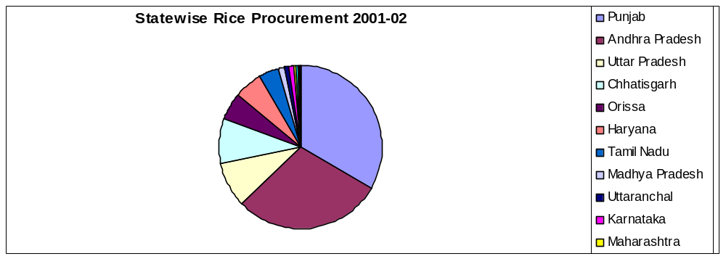Source: Statistics at a Glance, 2004, Ministry of Agriculture, Government of India.

In case of wheat procurement, Punjab was the major contributor with about 51 percent in the total quantum of procurement. The state of Haryana was the second largest contributor with the proportion of 31 percent and followed by Uttar Pradesh (12 percent). Rajasthan was contributing only 3 percent in the total procurement and rest of the sates (see fig 2.2) contributed almost similar proportion.

Fig 2.2: State-wise wheat procurement 2001-02 (‘000 tons)
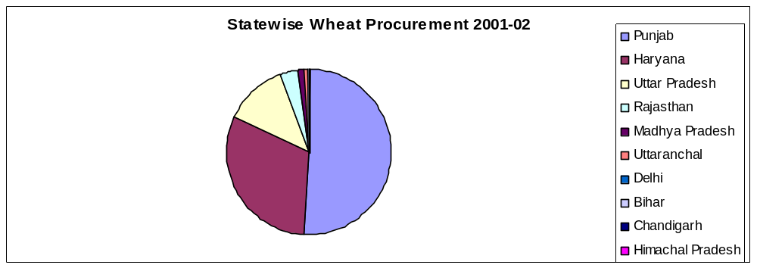 Source: Statistics at a Glance, 2004, Ministry of Agriculture, Government of India

Rice and wheat are the major cereals of India. These crops occupy a considerable share in the production of food crops in the country. The production of these crops is scattered across the regions as per their natural resource base and agro climatic conditions.

2.3.1 Rice Production:
Production of rice is widely scattered among the states of India. In the year 2001-02, the total production of rice in India was 93 million tons. The production share of different states are widely influenced by the consumption habits of the population for example West Bengal a major rice eating state occupies the prime position by contributing about 16 percent of all India production. Uttar Pradesh with a considerable area under rice production is the second major producer with its share in all India production equaling 14 %. Andhra Pradesh with a share of 12% is the third highest rice producing state. Though these three major rice producer states have a significant proportion in total rice production pie some other states like Punjab, Orissa and Tamil Nadu are also contributing considerably. Rest of the states together contribute about one third of total rice production (see fig2.3)

Fig 2.3: Percentage share of states in total production of rice in 2001-02
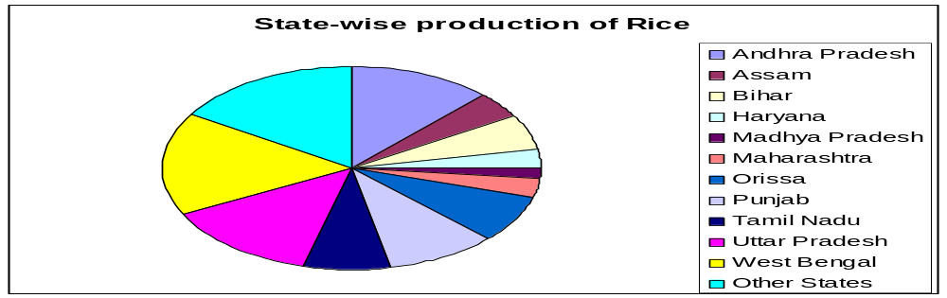Source: Statistics at a Glance 2004, Ministry of Agriculture, Government of India

2.3.2 Wheat Production:
All India production of wheat crop was 71million tons during 2001-02. There were wide variations in the level of production across the different states depending upon several conditions like availability of irrigation facility, climatic conditions etc. State like Uttar Pradesh alone was contributing more than one-third i.e. about 35 percent of all India production. Large proportion of the area is allocated to the wheat crop because of suitable natural factors like soil type, irrigation facilities and climate conditions. Punjab and Haryana occupy the second and third positions respectively by contributing about 22% and 13% share in the total wheat production. Some other states like Rajasthan and Madhya Pradesh also have the considerable production with about 9% and 8% respectively. One other reason could be the expansion of irrigation facilities across the different regions of the respective states. Bihar and Chhatisgarh though these states come lower in the overall ranking but still contribute 5 percent each in all India production (See fig2.4).

Figure2.4: State wise production of wheat
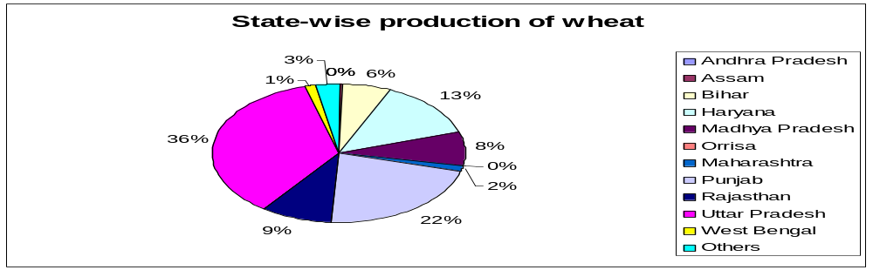

Source: Statistics at a Glance, 2004, Ministry of Agriculture, Government of India

2.4 Consumption Pattern of Rice and Wheat across Different States:
To estimate the consumption level of rice and wheat across the states, per capita NSS estimates for both urban and rural were taken into account. The estimates show that per capita consumption of rice and wheat varies across the states substantially. It is because of the variations in the food habits of the population, availability and price of the food grains. Traditionally the population in the states like Andhra Pradesh, Assam, Chhatisgarh, Jharkhand, Orrisa, West Bengal and other north-eastern states consume rice to a larger extent as compared to wheat. The people from Punjab, Haryana, Uttar Pradesh, Madhya Pradesh, and Rajasthan consume more wheat as compared to rice. The estimates relating to per capita consumption of rice and wheat for the country were as 82 kg and 51 kg respectively, which shows that consumption of rice is considerably higher than that of wheat (see table2.1).
Therefore, consumption level across the states depends on the per capita consumption of the preferred type of food i.e. rice and wheat and size of population. In case of consumption of rice, state of Andhra Pradesh occupies the prime position where about 15 percent of total consumption takes place followed by Orissa, Uttar Pradesh and West Bengal where about 11 percent with slight difference of the total consumption. Bihar and Tamil Nadu were consuming rice in nearly equal proportion i.e. 9 %. Other major rice consuming states are Chhatisgarh, Assam, Karnataka, Kerala and Maharashtra where consumption of rice varies from 4% to 6 % of the total national consumption. In other states, the quantity of rice consumed was limited in proportion.
Table 2.1: State wise per capita consumption of rice and wheat in kg 2001-02
State | Per Capita Consumption 2001-02 (in Kg)
 | Rice | Wheat
Andhra Pradesh | 142 | 3.
Assam | 145 | 7
Bihar | 91 | 72
Haryana | 11 | 122
Madhya Pradesh | 33. | 89
Maharashtra | 39 | 42
Orissa | 165 | 7
Punjab | 9. | 114
Rajasthan | 3 | 89
Tamil Nadu | 116 | 4
Uttar Pradesh | 52. | 103
West Bengal | 157 | 12
All India AVG | 82 | 51
Source: Calculated from NSS 55th round data

In case of wheat consumption, Uttar Pradesh was at the leading position with 27 percent of the total consumption. In case of consumption of rice, it was also one of the major states. It is because of the larger size of population living the state on the one hand and food habits on the other. The share of Rajasthan, Bihar and Madhya Pradesh in the consumption level of wheat was almost similar with slight differences. The major states of wheat consumption were Maharashtra, Gujarat, Punjab and Haryana where consumption of wheat varies between 4 to 6 percent.
It is noted from the analysis that there exist wide variations in the level of consumption of rice and wheat across the states. Largely, it may be attributed to the consumption habits of the population and its size in the concerned state.

2.5 Surplus/ Deficit Status of Rice and Wheat across the States:
We estimate the surplus and deficit of rice and wheat across the different states on the basis of per capita consumption, production and size of population in the concerned state.
The analysis shows that there were only six states which have the surplus of rice that can be made available for consumption in the deficit regions. West Bengal occupies the prime position in having the surplus stock followed by Punjab, Uttar Pradesh, Haryana and Chhatisgarh. Rajasthan also had surplus stock of rice, but it was in very limited quantity. In overall terms, there were about 17 million tons of surplus of rice in the country (see Table 1). The major states that have the deficit of rice in substantial quantum against their consumption are Kerala, Orissa, Bihar Karnataka, Madhya Pradesh, Jammu & Kashmir, Himachal Pradesh, Gujarat and Assam and some other states especially in north-east region (fig 2.5).

Fig 2.5: State wise Marketable surplus: rice 2001-2002
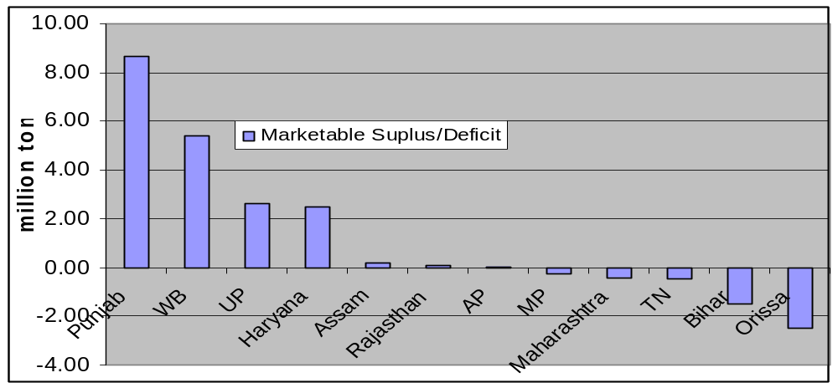
Source: Food Corporation of India,2003
In case of wheat, Punjab, Haryana, Uttar Pradesh and Rajasthan were the major states which had the surplus. Among these, Punjab has the leading position. The states like Himachal Pradesh and Jammu & Kashmir have also surplus of wheat but in limited quantity as compared to other states. In overall terms, there were about 11 million tons of rice and 20 million tons of wheat was available as state level marketable surplus in the country.

Fig 2.6: State wise Marketable surplus: wheat 2001-2002
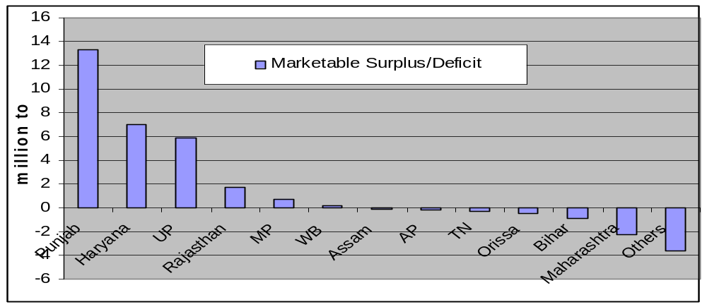
Source: Food Corporation of India, 2003

2.6 Implementation of Minimum Support Price (MSP)
In the present study, it is presumed that a state will be excluded for the in depth investigations where public agencies have been procuring the cereals under prevailing MSP at a very large scale. To verify the factual position, the procurement of wheat and rice across the states was analyzed. From the analysis, it is found that both central and state agencies were involved in procuring the rice and wheat across the states at varying levels (see table 1.2)
Effective implementation of MSP was done in a limited number of states. There were six and four states for rice and wheat respectively where MSP was implemented.

2.7 Level of poverty
The burden of MSP is correlated with poverty ratio in the states. The state has to make available rice and wheat to the poor households at the subsidized price that cause an increase in burden of provisioned MSP. Also price changes would show stronger impact on consumption expenditure.
The national level estimated poverty was around 26 percent. It can be noted from the fact that incidence of poverty in Bihar and Orrisa was considerably high at around 43 and 47 percent respectively. It was between 31 to 37 percent in three states like Uttar Pradesh, Assam and Madhya Pradesh. The figure relating to poverty in Maharashtra and West Bengal was comparable with that of national level estimates that can be considered as moderate. In the states like Punjab, Haryana, Himachal Pradesh and Jammu & Kashmir it was considerably lower (see fig 2.7)

Fig 2.8: State wise Poverty Ratio during 1990-2000
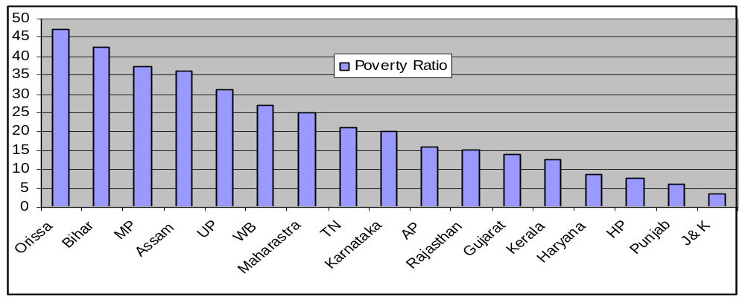
Source: Planning Commission, 2002
Note: All India Poverty Ratio is 26.1

2.8 States which can be selected
Production, consumption, and procurement are identified as three the major factors for short listing of states for the detailed analysis. The production consumption ratio (surplus_ratio) and procurement production ratio (proc_prdn) for both rice and wheat are plotted on Y-axis and X-axis respectively. Then states lying in the North Western section of the scatter plot will be short listed for the analysis. These states are those where we have surplus production and lower procurement. Thus these states can be potential candidate for selection. (See figure 2.5 & 2.6)
Taking above criteria into consideration from rice plot Uttar Pradesh, Rajasthan, Orissa, West Bengal, Tamil Nadu and Maharashtra are selected. Now from Wheat plot Uttar Pradesh, Rajasthan and Madhya Pradesh are selected.

Fig 2.9:Scatter plot rice
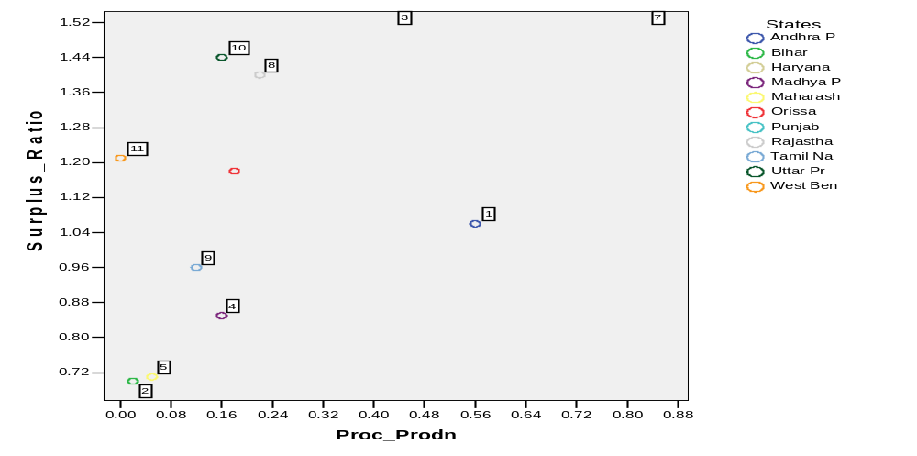

Fig 2.10 Scatter Plot Wheat
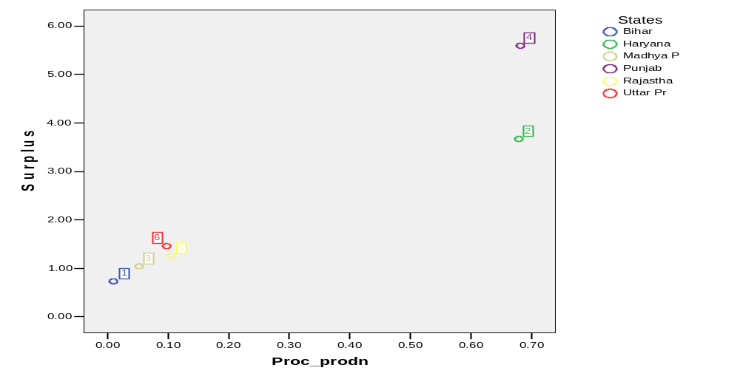 .
On the basis of overall criteria we have selected Uttar Pradesh and Madhya Pradesh for the analysis, which figure prominently both in rice and wheat scatter plot in the specified region.

Chapter 3

CASE STUDY

3.1 Agriculture Scenario – Baseline Information

3.1.1 Uttar Pradesh
Uttar Pradesh is the largest food grain producing state in India, producing about 22% of countries total food grain production. In 1997-98, contribution of Uttar Pradesh was 41.8 million tones in the national food grain production of 194.1 million tones. By the end of year 2007, food grain production in the state is expected to be at the level of 70.2 million tons in the total projected national food grain production of 300 million tones.
However the state is also characterized by widespread poverty and extreme dependence on agriculture. It is rich in natural resources (land and water) but has a high population density and declining soil fertility. It is the third poorest state of India with a per capita income of Rs 10817 in 2003-04 (sampark.chd.nic.in) The rural poverty rate is 21.5% representing a total of 28.3 million people or 15% of all poor in India. In year 2003-04 about 80 percent of the people in UP live in the rural areas; and 66% are dependent on agriculture for their livelihood. Agriculture accounts for 38% of GSDP (2001-02) (planning.up.nic.in).
According to the agriculture statistics 2004 the state has a geographical area 24.2 million hectares and out of this 16.8 million hectares area is actually cultivated and 3.98 million hectare area was un-irrigated.
Uttar Pradesh is largest producer of wheat in the country contributing about 36 % of the all India total wheat production whereas, UP is second largest producer of rice in contributing about 15 % to the national production in year 2003-04. The area under these crops is predominantly less than the contribution in terms of production.
In Uttar Pradesh 2.6 % of holdings is of more than 4 ha size and account for more than 19 % of the total area while about 75.6 % of the holdings accounting for 34.1 percent of the total area which clearly reflects severe inequities in ownership of land holdings. The state has about 16 million tons of surplus food grains after meeting its requirements.

3.1.2 Madhya Pradesh
Madhya Pradesh is predominantly an agrarian economy comprising of 74 percent population resides in rural areas, and is dependent on agriculture in direct or indirect manner. The share of agriculture and allied services accounts for almost 31 % share in the economy. The state is the fifth largest food grain producing state in India contributing about 7.43 % to total food grain production of India (Ministry of agriculture, 2003-04). However, the contributions of GSDP at current prices accounts for only 5.6% to total GDP [Human development report 2002]. In terms of per capita income, the relative position of Madhya Pradesh remained stable in relation to national per capita income; Uttar Pradesh experienced a continuous relative decline vis-à-vis the all-India level over the last four decades, Madhya Pradesh on the other hand registered a mild increase. The per capita income of Madhya Pradesh as a proportion of all-India per capita income was about 75% and has posited itself in the 12th rank at all India level. During the last decade, notably from 1991-92 to 1997-98 the rate of growth of gross state domestic product was 6.17 %. Madhya Pradesh, moderate growth has been accompanied by moderate decline in poverty over a long period with 37.06 % population below poverty line in 1999-2000. The growth per capita income in India has accelerated in the eighties and nineties relative to earlier period, and growth rates of most of the states have risen. For example, in the case of Madhya Pradesh, negative growth rates of per capita incomes in the sixties and seventies have been replaced by growth rates in excess of 2% per annum in the nineties, but the all-India growth rate has shot up by more than proportionately from around 1% per annum in the sixties and seventies to nearly 5% per annum in the nineties. For all States, the range of growth rates has widened, and if this persists, then economic disparities between states will continue to widen [Human Development Report (2004)].
Wide spread poverty is a common phenomena in Madhya Pradesh, having a per capita income of Rs.8384 where as the national average of per capita income is Rs.11799 in 2003-04 at 1993-94 constant prices (sampark.chd.nic.in ). Madhya Pradesh figures in the category of poor states of India with high incidence of poverty. About 73 % of the people in Madhya Pradesh live in the rural areas; and more than 70% are dependent on agriculture for their livelihood. Agriculture accounted for 25% of GSDP in 2002-03 (CMIE).
Madhya Pradesh occupies a significant position in total wheat production of the country with a contribution of about 9 percent of the all India production. Whereas in rice production it’s all India share is just 2 %. The area under these crops is substantially less than their contribution in terms of production.
Ever increasing population put pressure on limited land resources in all states pushed the land holding in a downward direction. In M.P the share of large and medium holdings of farmers are declining as well as the share of area operated by semi-medium holdings was also falling. A rise in the percentage of marginal holdings and a decline in percentage of holdings in all other categories have become common phenomena in Madhya Pradesh. The percentage of area operated by marginal holdings has been rising over the decades, while the percentage of area under small holdings has been rising at a slower pace. The concentration of size distribution of operational holdings in this state is evident from the Gini coefficient over the few decades which do not show any discernable change in the concentration of land. Distribution of land holdings in this state is highly skewed with average holding size is .4 hectares. There are 57% marginal farmers accounting for only 11% of cultivable area of the state and 20% are small farmer. In 2004-05 total area devoted to rice cultivation was 1623’000 hectare. The average yield of rice and wheat are 7.2quintals/hectare and 17.4 quintals per hectare respectively compared to all India average of 19.8 quintals and 26 quintals per hectors for rice and wheat respectively in 2004-05, indicating yield much below to all India average.

3.2 Data Analyzed

3.2.1 NSSO 55th Round Uttar Pradesh
The NSSO household level data from the 55th round, on consumption expenditures for wheat and rice has been analyzed for all the villages and than summed up for the whole state. The NSSO collects data, not only on food expenditures, but also on quantities purchased, so that the survey has been used to measure prices (unit values), and to examine how they vary across space and time. Price changes have efficiency effects, on the allocation of resources, and equity effects, on the distribution of real income across different households.
The NSSO data on household consumption expenditure provides information on the consumption patterns of a wide range of goods thus we have the Monthly Per capita Consumption Expenditure (MPCE) and the individual quantities consumed and the expenditure incurred for all commodities consumed by a household. The data also reveals information on the household characteristics of the sample such as household type, social group, nature of land possessed (e.g. whether owned or leased), income (Sources) and so on. This information has been taken into consideration for further analysis on the impact the proposed policy could have on the market prices of rice and wheat.
A preliminary analysis of the data revealed information on the percentage of households consuming Rice/Wheat bought from the PDS or from other sources; share of Rice/Wheat and the average unit value the households spent for rice/wheat.
Expenditure has been divided by the quantity consumed to arrive at the unit values of Rice and Wheat. The following table provides a glimpse of the consumption pattern of rice and wheat in 1999-2000 from the two sources namely the public distribution system and other sources apart from PDS. It is evident from the table 3.1 that, the share of households purchasing rice and wheat from the PDS is abysmally low, below 10% though the difference in magnitude of unit value of both rice and wheat between PDS and other sources is substantial. This implies that, greater accessibility of the households to PDS ensures low consumer expenditure.
Table 3.1: Unit values and percentage consuming rice and wheat from different sources, Uttar Pradesh, NSS 55th round 1999-2000.
Item | Source | % of households | Unit Value (Rs/Kg)
Rice | PDS | 7.75 | 5.95
Rice | Other | 90.93 | 9.42
Wheat | PDS | 7.33 | 4.82
Wheat | Other | 96.16 | 6.64
Source: Calculation of Figures is based on NSS 55th round 1999-2000. These all are simply un-weighted Means. Percentage consuming and share are in the percentage; unit values in 1999-2000 are in the rupees per kilogram

3.2.2 NSSO 55th Round Madhya Pradesh
Madhya Pradesh reveals a scenario similar to that of Uttar Pradesh, but this state ensured a marginally larger penetration of public distribution system in terms percentage share of households covered under the PDS. But, unfortunately the unit value of rice and wheat in this state is higher than Uttar Pradesh in terms of both of these two major sources (PDS and other sources) (see table3.2).

Table 3.2: Unit values and percentage rice and wheat from different sources, Madhya Pradesh, NSS 55th round 1999-2000.
Item | Source | % of households | Unit Value (Rs/kg)
Rice | PDS | 11.70 | 6.71
Rice | Other | 88.30 | 11.47
Wheat | PDS | 9.40 | 4.87
Wheat | Other | 90.60 | 7.37
Source: Calculation of Figures is based on NSS 55th round 1999-2000. These all are simply un-weighted Means. Percentage consuming and share are in the percentage; unit values in 1999-2000 are in the rupees per kilogram

3.2.3 NSSO 60th Round Uttar Pradesh
In 60th round the major change identified in Uttar Pradesh is the percentage share of households purchasing rice and wheat from PDS falls significantly. It tells a story of decreasing penetration of PDS system. This could be attributed to either falling popularity of the system or inefficiency in terms of reach and food grains availability to the consumer on time. One interesting observation here is the prices of both wheat and rice made available through the PDS system have decreased compared to 1999 in 2004. On the other hand prices of wheat and rice available under non PDS system have risen by a slight margin (see table3.3).
Table 3.3: Unit values and percentage consuming rice and wheat from different sources, Uttar Pradesh, NSS 60th round 2004
Item | Source | % of households | Unit Value (Rs/kg)
Rice | PDS | 1.4 | 5.25
Rice | Other | 98.6 | 10.06
Wheat | PDS | 1.5 | 4.08
Wheat | Other | 98.5 | 6.83
Source: Calculation of Figures is based on NSS 60th round 2004. These all are simply un-weighted Means. Percentage consuming and share are in the percentage; unit values in 2004 are in the rupees per kilogram

3.2.4 NSSO 60th Round Madhya Pradesh
In 2004, Madhya Pradesh experienced comprehensive changes in distribution of rice. The significant rise in the percentage of households served through PDS is seen in case of rice, whereas for wheat the proportional coverage under PDS has declined from the previous level of 1999-00 (see table3.4).
Table 3.4: Unit values and percentage consuming rice and wheat from different sources, Madhya Pradesh, NSS 60th round 2004
Item | Source | % of households | Unit Value (Rs/kg)
Rice | PDS | 18.3 | 6.03
Rice | Other | 81.7 | 12.12
Wheat | PDS | 6.10 | 4.90
Wheat | Other | 93.90 | 7.12
Source: Calculation of Figures is based on NSS 60th round 2004. These all are simply un-weighted Means. Percentage consuming and share are in the percentage; unit values in 2004 are in the rupees per kilogram

Chapter 4

Methodology and Analysis
This study tries to find out the fiscal implication of extension of MSP in terms of required budgetary support and gain/loss to consumers’ and producers. Consumers’ gains or losses are calculated in terms of change in total consumption expenditure on wheat and rice on account of change in local market prices of wheat and rice as a result of extended MSP. Consumption from market (home grown wheat and rice consumed is clubbed with market purchased wheat and rice) and PDS are also taken into account. Producers’ gains or losses are accounted in terms of their total receipts by selling their produce (wheat and rice). Change in receipt of producer from wheat and rice sold to market and procurement agencies is calculated separately and added up to calculate net receipt of producers’.

4.1 Data used for the analysis
NSSO 55th round and NSSO 60th round consumer expenditure data, district wise production data from CMIE, district wise procurement data from FCI and Directorates of Economic and Statistics of Madhya Pradesh and Uttar Pradesh and district wise population data from Census 2001 are used for the analysis.
Table 4.1 No of Districts (No. of data points) considered for regression analysis
Uttar Pradesh |  |  |  | Madhya Pradesh
NSSO 55th round |  | NSSO 60th round |  | NSSO 55th round |  | NSSO 60th round
Rice | Wheat | Rice | Wheat | Rice | Wheat | Rice | Wheat
60 | 58 | 70 | 70 | 44 | 34 | 41 | 24

4.1.1 District level market price (MP)
NSSO collects data for the quantity consumed and the imputed value based on 30 days recall period for all the items consumed by a household. Imputed value by NSSO for an item consumed is divided by the total quantity consumed of the same item; this is referred as a unit value. Simple arithmetic mean of unit values of all the samples (corresponding to households) in a district is taken as market price (MP).
Market Price (MP_{j}) = [∑^{Nj}_{i=1}{(Value30)_{I} / (Quatity30)_{I}}] / (Sample size of district “j”)
Where (Value 30)_{I} = Value in Rupees, spend on rice/wheat (depending upon which price has to be calculated) by a household “I” in the last 30 days, based on 30 days recall period.
(Quantity 30)_{I} = Quantity of rice/wheat (depending upon which price has to be calculated) consumed by a household “I” ” in the last 30 days, based on 30 days recall period.
N_{j} = No of samples in a district “j” taken by NSSO.
J is a particular district of a state.

4.1.2 District level Harvest Price (HP)
Quantity consumed and imputed values for an item is disaggregated by the source by the NSSO survey i.e. source of each consumed items are mentioned as per their source in the survey. Simple arithmetic mean of Unit values of all home grown item used for personal consumption by the entire sample in a district is taken as farm harvest price (HP).

4.1.3 District level Procurement (Q_{p})
Total procurement is calculated by adding up district wise procurement by FCI and state procurement agencies obtained from FCI and Directorates of Economic and Statistics Madhya Pradesh and Uttar Pradesh respectively. Total procurement in a district is divided by population total of the district obtained from Census 2001 to get per capita procurement.

4.1.4 District level per capita consumption
NSSO reports total quantity consumed for an item by a household and household size for the samples. Total quantity consumed by a household divided by respective household size gives per capita consumption by the sample household. Simple arithmetic mean of all the samples from a district is calculated to get per capita consumption of an item.
Per capita consumption
(c_{j}) = [∑^{Nj}_{i=1}{(Quatity30)_{I} /(household size)_{i}}] / (Sample size of district ‘j”)
Where: Quantity of rice/wheat (depending upon which quantity has to be calculated) consumed by a household “I” ” in the last 30 days, based on 30 days recall period.
N = No of samples in a district taken by NSSO
J is a particular district of a state.

4.1.5 District level production
District wise production of wheat and rice are taken from CMIE (Centre for Monitoring Indian Economy). Production is divided by the district wise population reported by Census 2001.

4.2 The model framework
To measure the gain of producer, additional farm income has been calculated. Consumer gains are estimated in terms of change in food (Rice and wheat) expenditure, ceteris paribus (keeping quantity of rice and wheat consumed as it is). To make the model simple likely change in production due to change in output price is not accounted.

4.2.1 New market price (MP*) with extended procurement system
We consider a log-log linear model for calculation of MP*, which is defined as the retail market price that would prevail when procurement at MSP is carried out in all districts. Market price is a function of production per capita and harvest price. Market price can be expected to be a function of quantity supplied and cost of production. Higher per capita production will lead to a higher marketable surplus, as it is surplus of per capita production over per capita self-consumption and lower market price. Farm harvest price (HP) is a proxy of cost of production. Higher cost of production would lead to a higher market price.
Ln(MP) = α₁ + β₁ Ln ( Prdn per cap) + γ₁ Ln (HP)……………(4)

Where “prdn” stands for production

Fig. 4.1 Production Per capita for wheat against market price for Uttar Pradesh
Mprice
prdnpercapqntl
3.50
3.25
3.00
2.75
2.50
2.25
2.00
1.75
1.50
1.25
1.00
0.75
0.50
8.00
7.50
7.00
6.50
6.00
5.50
Moradaba
Mirzapur
Meerut
Mathura
Mainpuri
Maharajg
Lucknow
Lalitpur
Kanpur N
Kanpur D
Kannauj
Jyotiba
Jhansi
Jaunpur
Jalaun
Hardoi
Hamirpur
Gorakhpu
Gonda
Ghazipur
Ghaziaba
Firozaba
Fatehpur
Farrukha
Faizabad
Etawah
Etah
Deoria
Chitrako
Chandaul
Bulandsh
Budaun
Bijnor
Basti
Bareilly
Bara Ban
Banda
Balrampu
Ballia
Bahraich
Baghpat
Azamgarh
Auraiya
Allahaba
Aligarh
Agra
Districts
Note: Mprice- Unit value calculated from NSSO 55th round data (it is a ratio of total last 30 days expenditure and total quantity consumed of last 30 days).
Prdnpercapqntl – Production per capita in quintal

From the scatter plot it is evident that Production Per capita (quintal) and unit price are inversely related i.e. higher per capita production will lead to lower per unit price. This result is quite obvious as it follows the general demand and supply rules of economics, which says inverse relation of supply and price under ceteris paribus (No change in demand). This implies that higher production per capita ensures rise in aggregate welfare by ensuring low unit price and make greater availability of food grains to the poor
Fig 4.2 Procurement production ratio for wheat against market price for Uttar Pradesh
procprdnpercentage
0.40
0.36
0.32
0.28
0.24
0.20
0.16
0.12
0.08
0.04
0.00
Mprice

8.00
7.50
7.00
6.50
6.00
5.50
Moradaba
Mirzapur
Meerut
Mathura
Mainpuri
Maharajg
Lucknow
Lalitpur
Kanpur N
Kanpur D
Kannauj
Jyotiba
Jhansi
Jaunpur
Jalaun
Hardoi
Hamirpur
Gorakhpu
Gonda
Ghazipur
Ghaziaba
Firozaba
Fatehpur
Farrukha
Faizabad
Etawah
Etah
Deoria
Chitrako
Chandaul
Bulandsh
Budaun
Bijnor
Basti
Bareilly
Bara Ban
Banda
Balrampu
Ballia
Bahraich
Baghpat
Azamgarh
Auraiya
Allahaba
Aligarh
Agra
Districts
Note: Procprdnpercentage – Procurement in quintal to Production in quintal ratio

Procurement Production percentage does not have a significant impact on the unit prices (fig 4.2) means procurement is not found to be a considerable determinants of local market price. But since procurement is not happening at a high percentage (Most of the districts fall below 10 percent of production procurement percentage) we could not substantiate the above hypothesis empirically.
Table 4.2 Number of districts where procurement activities are substantial
States | Years | Rice |  |  | Wheat
 |  | HP>MSP | HP=MSP | HP<MSP | HP>MSP | HP=MSP | HP<MSP
UP | 99-00 | 54 | 0 | 0 | 49 | 0 | 9
UP | 2004 | 47 | 0 | 0 | 43 | 1 | 15
MP | 99-00 | 5 | 0 | 0 | 31 | 1 | 7
MP | 2004 | 6 | 0 | 0 | 17 | 0 | 7
Note: HP> MSP (There is no surplus to sell to procurement agencies)
HP = MSP (MSP is dominant)
HP <MSP (There is surplus but inadequate procurement)
With the extension of procurement system by ensuring greater participation of nodal procurement agencies (FCI and state procurement agencies) by opening up procurement center in those areas which are so far uncovered and deprived from getting the benefits of procurement, farmers in those areas also would be having an option to sell their produce to the procurement agencies at MSP. This new options will have an implication on the farmers realized price for crops (wheat and rice). This new realized price HP* would be as follows:
HP* = Max (HP, MSP) …………………………….. …… (5)
Substituting HP by HP* in equation (4) we get new market price (MP*) which shows an implication of extended MSP on the local market price.
MP* = antilog {α₁ + β₁ Ln (Prdn per cap) + γ₁ Ln (HP*)}…………….. (6)
Here only those districts where farm harvest price is more than procurement prices (prices received by farmers) are considered. Because it is assumed that those districts where farm harvest price is higher than the procurement price farmers will not come forward to sell their produce to government procurement agencies. In other words procurement would not be effective in those districts. But this firm belief is based on the assumption that there should be some easily accessible alternate market where local market prices should be higher than procurement price or at parity to farm harvest price. Other wise in case of no alternate options producers have to sell at least a part of their produce to whosoever is willing to buy at the prevailing harvest price only.

4.2.2 Procurement (Q_{p}*) with extended procurement system
We assume that a farmer is a price taker with her total production of rice and wheat. She sells some proportion of her output (q₁) at the Minimum support price (MSP) and retains a part (q₂) of it to sells later at market price (MP*) as a result of extended Procurement operation. If we assume perfect foresight her problem is to decide the total, how much to sell at harvest price and how much to retain for later sale at market price (MP*).
Maximize objective function
Realized income of farmer (Z) = MSP × (q₁× Q) + MP* × (q₂ × Q) ………. (7)
Where Q = Total production of rice or wheat
First order condition of equation (7)
d (Z)/d (Q) = 0 gives
or 0 = MSP × (q₁) + MP* × (q₂)
or ( q₁ / q₂ ) = - (MP*)/ MSP
The government determines MSP. It is fixed so the fraction of quantity sold in market at market price and to procurement agencies is a function of market price.
i.e. q1 = α f (MP*) Where q1 is the fraction of quantity procured to total surplus production by procurement agencies.
By taking logarithm both side we have
Ln (Q*_{p}) = α₂ + β₂ Ln(MP*) ………………(8)

4.2.3 Change in producers’ income

Market price (MP) is regressed against per-capita production and farm harvest price (HP) and in the obtained equation (4) harvest price is substituted by the effective realized price (HP*) (under the extended procurement system) by the farmers (equation 6).
Producers are important agents and their income has a direct co-relation with the welfare of the society as a whole. Producers consist of a large chunk of small and marginal farmers in India, which is a highly vulnerable section of society. A large group of small and marginal farmers in India make an effective lobby.

Change in Producers’ Income = ([IP* -IP]/IP) × 100

Where,

IP = MP (Q – Q_{p}) + Q_{p} × MSP …………………….. (9)

IP* = (MP*) × (Q-Qp*) + (Qp*) × (MSP)………………(10)

Where IP = Producer income initial
IP* = Producer income with extended procurement system
Q = Total production
Q_{p} = Procurement before the introduction of extended procurement system (Existing level of procurement)
Q_{p}* = Quantity procured with extended procurement
MP* = Changed market price after the extension of MSP.

4.2.4 Change in consumers’’ expenditure

Consumers’’ gains are calculated in terms of expenditure on rice and wheat, where it is assumed that the increase in their prices is not going to change the consumption pattern. Low level of per capita income and widely skewed income distribution bring about a larger section of poor people in society, with high marginal propensity to consume of food grains. This section gets highly affected and consequently their consumption pattern changes, even with a small rise in food grains price.

Reference Scenario, Consumer expenditure (C_{e}) |  |  |  | New scenario, consumer expenditure (C_{e}*)
Quantity Consumed |  | Prices |  | Quantity Consumed |  | Prices
PDS (Q_{p}) | Market (Q-Q_{p}) | PDS (P^{r}) | Market (MP) | PDS (Q_{p} + δQ_{p}) | Market (Q-Q_{p} - δQ_{p}) | PDS (P^{r}) | Market (MP*)

Where δQ_{p} is the change in procurement quantity due to extension of procurement.
Or δQ_{p} = (Q*_{p} – Q_{p})
Consumer total expenditure is sum of product of quantities consumed and price (depending on the source market or PDS)

Change in consumer expenditure is [(C*_{e} - C_{e})/C_{e}] × 100

To calculate (C_{e}*) we make following assumptions

- People can purchase either from market or from PDS depending upon price. Total quantity consumed of rice and wheat remains constant.
- All that is being produced is either sold in open market or to procurement agencies.
- Consumer faces two prices
  - PDS price (P^{r})
  - Market price (MP*)
- All that is procured is sold through PDS @ subsidized price.

4.3 Change in fiscal outlay
If we assume that all the additional procurement is distributed in the state through PDS at ration prices, then the additional fiscal outlay is as follows.
Change in Fiscal Outlay = (MSP – P^{r}) × (Q_{p}* - Q_{p})
Where Q_{p}* = Quantity Procured with extended MSP system
Q_{p} = Quantity procured before extension of MSP
However, if this additional procurement does not lead to any additional distribution through PDS, but merely replaces what was brought earlier from the other states, there will be a saving in transport cost. This saving in transport cost is not accounted in this analysis.

Chapter 5

Findings of the study

Using district wise procurement (wheat and rice) data, NSSO 55th round consumption survey household level data and district wise production (wheat and rice) data for FY 1999-00, we have estimated econometrically the equations described in chapter 4 relating different prices, production levels and procurement quantities. Using the estimated equations changes in producers’ income and consumers’’ expenditures and budgetary support (fiscal outlay) required to carry out extensive procurement have been analyzed.

5.1 Regression Results
Following tables 5.1, 5.2, 5.3 and 5.4 summarize the regression results for both rice and wheat for Uttar Pradesh using data sets discussed in sub-section 4.1.
To analyze the impact of extended procurement regime for Madhya Pradesh the same elasticities as used for Uttar Pradesh have been used. Procurement does not widely prevail in Madhya Pradesh (not sufficient data Points). We believe that once procurement is extended in Madhya Pradesh not only intensively (increasing penetration in the districts where it prevails currently) but also extensively (bringing new districts under procurement) we assume that Madhya Pradesh is likely to exhibit similar pattern of behavior as Uttar Pradesh. This justifies the logic of taking the same elasticities for Madhya Pradesh as have been used for Uttar Pradesh.
Table 5.1 Regression result for 1999-00, rice Uttar Pradesh
Dependent Variable | Independent variables | Co-efficient | t-stat | Rsquare | No. of  observations | F-stat
Market Price | Constant | 1.215 | 7.364 | .619 | 59 | 45.05
Market Price | Production Per cap | -.034 | -8.003 | .619 | 59 | 45.05
Market Price | Farm Harvest Price | .548 | 3.371 | .619 | 59 | 45.05
Procurement per capita | Constant | 15.482 | 4.686 | .293 | 54 | 21.568
Procurement per capita | (Market Price) | -.693 | -4.464 | .293 | 54 | 21.568

Table 5.2 Regression result for 1999-00, wheat Uttar Pradesh
Dependent Variable | Independent variables | Co-efficient | t-stat | Rsquare | No. of  observations | F-stat
Market Price | Constant | .948 | 5.526 | .785 | 58 | 99.03
Market Price | Production Per cap | -.066 | -4.672 | .785 | 58 | 99.03
Market Price | Farm Harvest Price | .708 | 10.031 | .785 | 58 | 99.03
Procurement per capita | Constant | 49.972 | 7.240 | .473 | 58 | 50.350
Procurement per capita | (Market Price) | -25.841 | -7.096 | .473 | 58 | 50.350

Table 5.3 Regression results for 2004, rice Uttar Pradesh
Dependent Variable | Independent variables | Co-efficient | t-stat | Rsquare | No. of  observations | F-stat
Market Price | Constant | .001 | .045 | .997 | 70 | 113.59
Market Price | Production Per cap | -.005 | -1.247 | .997 | 70 | 113.59
Market Price | Farm Harvest Price | 1.006 | 114.036 | .997 | 70 | 113.59
Procurement per capita | Constant | 14.310 | 7.997 | .559 | 47 | 57.134
Procurement per capita | (Market Price) | -5.974 | -7.559 | .559 | 47 | 57.134

Table 5.4 Regression result for 2004, wheat Uttar Pradesh
Dependent Variable | Independent variables | Co-efficient | t-stat | Rsquare | No. of  observations | F-stat
Market Price | Constant | -.057 | -1.696 | .982 | 70 | 178.6
Market Price | Production Per cap | -.001 | -.831 | .982 | 70 | 178.6
Market Price | Farm Harvest Price | 1.028 | 59.236 | .982 | 70 | 178.6
Procurement per capita | Constant | 17.130 | 3.898 | .176 | 54 | 12.196
Procurement per capita | (Market Price) | -8.030 | -3.492 | .176 | 54 | 12.196

The responsiveness of wheat can be seen in the estimation of the log-log equation 4 (table-5.2) for 1999-00. The negative elasticities of market price (unit value) with respect to per capita production signify that sufficient availability of these two food grains would dampen the market price and vice versa. The magnitude of the elasticity is higher for wheat than rice. Another variable, the farm harvest price (FHP) also affects market price (unit value). An increase in FHP would also boost the market price to go up and vice versa. Similarly as in previous case, the degree of sensitivity of market price for wheat is higher compared to the sensitivity of market price of rice in response to the changes in FHP of wheat and rice respectively as for rice consumers’ can switch quality of rice consumed with change in price.

Elastcities are small and smaller for 2004 than 1999-00. From the 60th round data of 2004 for Uttar Pradesh we see that the impact of extending MSP. The estimated coefficients indicating the respective elasticities for rice and wheat show a significant deterioration in their absolute magnitude compared to the elasticities from the 55th round data. The market price is almost insensitive to change in per capita production. This can perhaps be explained by the intervention of the Government in providing widely the support price, which can dampen the direct relationship between market price and per capita production (by mitigating risk). The risk and uncertainty in terms of price volatility in the open market scenario can be reduced by the extension of the peripheral boundary of MSP.

For 2004 the market price is largely determined by the farm harvest price. With an extended MSP regime, where farmers in all districts can sell all their output at MSP, market price will be independent of production but highly dependent on farm harvest price, i.e. MSP in this case. Thus the elasticity of market price with respect to per capita production is virtually zero in 2004.
The elasticities of per capita procurement with respect to market price are all negative as expected and statistically significant. Farmers’ decision conceiving how much to sell to procurement agencies depends on expected market price. Thus, high expected market price means lower procurement.

5.2 Impact on the consumers’
It is found that In Uttar Pradesh consumers’’ experience a mixed outcome. On the one hand as a result of change in market price of wheat and rice their expenditure on rice decreases by 0.26% and on the other hand expenditure on wheat increases by 2.3%, assuming ceteris paribus (quantities of wheat and rice consumed by the households remain constant). The estimated equation co-efficient are as per expectations. The elasticity of market price (unit value) with respect to per capita production, as expected is negative for both wheat and rice and for both 1999-00 and 2004 for Uttar Pradesh. But in Madhya Pradesh gain to consumers’ are clear, as consumer expenditure reduces by 7.44 % for rice and 0.20% for wheat. Change in consumer expenditure is attributed to change in market price of wheat and rice as a result of extension of procurement system (table5.5).

Table 5.5 Percentage change in consumers’ expenditure and producers’ income with the extension of MSP for FY 1999-00
 | MP |  | UP
 | Rice | Wheat | Rice | Wheat
Producers | 8.73 | 0.67 | 1.29 | 2.59
Consumer | 7.44 | .20 | 0.26 | -2.3
Note: + sign for producers’ shows, there is a rise in producers’ aggregate realization from the sale of food grains. + Sign for consumers’ shows, there is a reduction in consumer expenditure as a result of saving on the purchase of food grains consumed on account of decreased price.

If we look at consequent changes caused by extending MSP in 2004, consumers’ expenditure on rice in both the states has increased but for wheat their expenditure has reduced (table5.6).

Table 5.6 Percentage change in consumers’ expenditure and producers’ income with the extension of MSP for FY 2004
 | MP |  | UP
 | Rice | Wheat | Rice | Wheat
Producers | -0.91 | 1.22 | 0.47 | 0.90
Consumer | -1.66 | 2.83 | -0.16 | 1.09
Note: + sign for producers’ shows, there is a rise in producers’ aggregate realization from the sale of food grains. + Sign for consumers’ shows, there is a reduction in consumer expenditure as a result of saving on the purchase of food grains consumed on account of decreased price.

The effect of extension of MSP has not been realized assertively across time and across commodities, as consumers’ expenditure on rice reduces in Madhya Pradesh in 1999, but increases in 2004. Similar pattern is exhibited by consumers’ in Uttar Pradesh also in across the time analysis. For wheat consumers’ expenditure is showing a positive gain for both the states for both the time periods. Concluding, it can be said that extension of MSP has a positive implication for wheat consumers’ but the rice consumers’ may get worse off.

5.3 Impact on Producers’
Extension of MSP improves income of both rice and wheat producers’. Rice producers register an increase in their income of 1.29% from the sale of rice whereas wheat producers post an additional gain of 2.59% in their income in year 1999-00 in Uttar Pradesh. In Madhya Pradesh rice producers’ income in 1999-00 is increasing by 8.73% and 0.67% for rice and wheat respectively (table5.5).

Income of rice producers is decreasing by .91% but for wheat their income is increasing by 1.22% with the extension of MSP in 2004.The result shows a gain for both rice and wheat producers of .47% for rice and .90% for wheat in year 2004 in Uttar Pradesh.

Extension of MSP improves income of both rice and wheat producers across the states and across the time periods analysis, except for rice producers in Madhya Pradesh, their realization is showing a decline in year 2004.

5.4 Impact on fiscal outlays
Extension of MSP increases the total volume of procurement substantially and consequently the budget required for supporting procurement increases. For wheat budgetary support increases by approximately 3 times whereas for rice it increases by 2 times of the existing level.

The percentage change in fiscal outlay of the larger procurement is higher for wheat [339.6%] in comparison to fiscal outlay of rice 226.8% in 1999-2000 in Uttar Pradesh. In 2004, this fiscal outlay is significantly reduced by almost 127.6 % and 231.7 % for rice and wheat respectively (table 5.3). The substantial amount of fiscal outlay in the reference period can be attributed to the fact that, most of the districts in Uttar Pradesh have considerable quantities of these food grains left for procurement which can be captured by extending MSP. This process of extension of MSP covering these sizeable amounts of rice and wheat increases fiscal outlay.

Table 5.7 Percentage change in fiscal outlay due to change in procurement quantity under extended procurement regime.
 | MP |  | UP
 | Rice | Wheat | Rice | Wheat
1999-00 | 8.86 | 521.9 | 226.8 | 339.6
2004 | 28.45 | 138.5 | 99.2 | 107.9
Note: + sign shows there is a rise in fiscal outlay

As the mechanism of extension process progresses enhancing greater opportunities, in the final round, the fiscal burden reduces significantly as there remains little scope and provision of extending MSP in these same districts. So, as the scope has been narrowed down between these years of progress, the increase in fiscal burden when MSP is extended by the Government will necessarily get reduced, implying the fall in fiscal burden in 2004 and an improvement in efficacy of the extension mechanism of minimum support price programme.

Chapter 6

Conclusion and Recommendations
Although, with the inception of Green Revolution productivity and consequently production increased substantially and country become from a food deficit to a food surplus one, in recent years government had again to import food gains. This changing landscape of food demand and supply supplement the motivation to look into the policies concerning PDS.

To encourage production the government announces a minimum support price (MSP) for a number of crops. These prices are enforced by purchases at MSP by the Food Cooperation of India (FCI) of whatever quantity is offered. These operations however, are carried out only in selected states and mandies. As a consequence food grain prices in other regions and markets may fall below the MSP. Also procurement of food grains in only selected places involves additional transport to distribute the grain in the Public Distribution System (PDS). It has been suggested that procurement operations should be extended to all states.

Extension of procurement system to bring more and more districts with extensive as well as intensive coverage of the procurement system has wider implications on producers and consumers’. Producers of districts where market price was below MSP will get higher price and higher incomes. On the other hand consumers’ will have to pay a higher price for their purchase from the market.

In this study the Extended Procurement regime is evaluated in terms of i) Increase/decrease in consumers’ expenditure on wheat and rice assuming that the quantity of rice and wheat consumed would remain constant. The change in expenditure is on account of changing effective price (weighted price of wheat and rice available from PDS at PDS price and quantity purchased from market at market prices). ii) Increase/decrease in producers’ income as a result of change in effective realized price by the producers. Price changes as a result of extension of procurement regime. iii) Change in fiscal outlay to carry out extended procurement. This is done by exploring what would have happened had EMSP regime been operated in two states Uttar Pradesh and Madhya Pradesh in two past years, 1999-00 and 2004.

Stimulation of EMSP in 1999-00
- Producers’ gain/loss
Producers of Uttar Pradesh are registering a proportionate gain over their current income (from sale of rice and wheat) of 1.29% for rice and 2.59% for wheat. In Madhya Pradesh Producers are posting a gain of 8.73% and 0.67% for rice and wheat respectively. This increase in income of producers is the result of higher realized prices (wheat and rice) by the producers. This high realization of produce by the food growers is on account of prevalence of price support.
- Consumers’ gain/loss
Analysis shows consumers’ of Uttar Pradesh experience an ambiguous response from the extension of MSP as their consumption expenditure for rice decrease but it increases for wheat. On balance a consumer gains or losses depending on her relative consumption of wheat and rice. In Madhya Pradesh gains are positive for consumers’ for both rice and wheat.
- Fiscal implications
Support required to carry out extended procurement system is quite substantial. It increases by approximately 2 and 3 times for rice and wheat respectively for Uttar Pradesh. For Madhya Pradesh extended procurement regime does not result in a substantial increase in budgetary support required for rice but for wheat it is approximately 5 times of the existing level.

Extension of MSP has a positive implication for both consumers’ and producers in terms of increased income by producers from the sale of produce and decreased expenditure by consumers’ under ceteris paribus (quantity of wheat and rice consumed by consumers’, production quantity of wheat and rice produced by producer remain constant). This positive gain by both producers’ and consumers’ enhances the aggregate gain of the society by translating the fiscal support in the aggregate gain of producers’ and consumers’.
Cost of extended procurement system in terms of fiscal support needed is substantial. But the states taken for the case study initially had few districts under coverage but under the new system entire states are coming under the coverage. Inclusion of these new districts under the procurement operation is largely responsible for a multiple fold increase in fiscal outlay.

The net gain to producer and consumer however, outweigh the additional fiscal outlay It is also worth noting that we have assumed that the procurement under extended MSP regime is additional to what governments purchase. In the situation where the amount distributed is kept constant and what is not procured by the state is procured by the central government in some other state and brought to the state, the fiscal outlay would be larger as it would also involve the transport cost. In this case however, we should not consider that additional procurement within the state is additional distributions to consumers’ by the state through PDS. Thus the gains to consumers’ would be very different. Since higher procurement implies higher market price, where higher procurement does not result in larger distribution through PDS consumers’ expenditure would go up. We have not analyzed this situation.

Stimulation of EMSP in 2004
Producers’ gain/loss
Uttar Pradesh has showed an increase in producers’ proportionate income by 0.47% and 0.90% for rice and wheat respectively. In Madhya Pradesh while wheat producers’ income increases by 1.22% and rice producers income decreases by .91%

Consumers’ gain/loss
Consumers’ in Uttar Pradesh are showing indistinct response with the extension of MSP like the previous period analysis. Consumers’ expenditure is rising for rice while it is decreasing for wheat. In Madhya Pradesh consumption expenditure for rice is getting hit but for wheat it is a gain for consumers’.

Fiscal implications
Fiscal support required to carry out extended procurement under this period is also quite substantial like the previous period analysis.

Analysis of extended MSP system in year 2004 also shows similar pattern as exhibited by period 1999-00. From this analysis it is apparent that producers are gaining substantially in both the states for both rice and wheat during both the analysis period. Gains to the consumers’ are however, ambiguous. Proportion of wheat and rice in the consumer food grain basket would determine the gain/loss of consumer in true sense.

Since procurement increases under EMSP it implies that there are food grains available for procurement and districts which require MSP support through the extension of procurement.

Bringing more districts under MSP by opening up procurement centre in remote areas provide an alternate option to the farmers for selling their produce to the procurement agencies at a pre-determined price. This can ultimately reduce the vulnerability of farmers to the volatility of prices i.e protecting them against the down side risk. This is all the more necessary with the rising input cost of cultivation. Diminishing risk for food grains due to EMSP system would influence farmers cropping decision in a way. It induces farmers to plant crops having low risk factor involved in resource poor regions.

From the analysis it is seen that the gain accruing to the society (Producers’ and consumers’ of rice and wheat) is at the cost of rising fiscal burden. It is still an open ended question by this analysis that whether the rise in fiscal burden is compensated by the aggregate gain to the societies or not. Rice and wheat figures prominently in the food grain basket of the people. One would therefore expect that the gain to people, particularly the poor ones, would offset the impact of higher fiscal outlay.

References
Kalhon, A.S, Tyagi, D. S (19830, Agriculture price policy in India, Allied Publishers, India
Acharya, S. S. (2001) “Domestic Agricultural marketing Policies, Incentives and Integration,” Indian Agricultural Policy at the Crossroads, Rawat Publications, Jaipur
Acharya, S. S. and Jogi, R.L. (2003), “Minimum Support Prices for Agricultural Commodities in India: Some Issues”, Working Paper 132, Institute of Development studies, jaipur.
Angus Deaton, Parikh, Kirit and Subramanian (1994) “Food Demand Pattern and Pricing in Maharashtra: An Analysis Using Household Level Survey Data” Sarvekshana, October-December.
Jha, Shikha and Srivasan, P.V. (2006) India Reforming Farm Support Policies for Grains, Indira Gandhi Institute of Development Research, Mimbai.
Administrative Staff College of India Hyderabad, (2001) “The Cost of Acquisition and Distribution of Food grains”
Acharya, S. S. (1989) “Agricultural Marketing in India: Some Facts and Emerging Issues”, Indian Journal of Agricultural Economics, Vol.53, No. 3.
Acharya, S. S. (1999) “Agricultural Marketing: Issues and Challenges” Indian Journal of Agricultural Economics, Vol., 53 No. 2
Acharya, S. S. (1999) “Domestic agricultural Reform in India”, in Chand Ramesh and Arora VPS (Ed) Agricultural Input and Output Market reform in India (Conference Proceeding), Agricultural Economics Research Association, New Delhi.
Acharya, S. S. and Chaudhari D.P. (2001) “Equity-Driven Trade and Marketing Policy Strategies for Indian Agriculture: Priority and Agenda” (Ed.) Indian Agricultural Policy at the Crossroads, Rawat Publications, Jaipur.
Connell, Peter, Hagi Shirshore, Hirad and Jahan, Nilufar (2004) “Indian Agriculture: Trends, Trade and Policy Reform”, Australian Commodities, Vol. 11 no.4.
Dantwala, M. L. (1996) “My Dialogues: Agricultural Price Policy and the Green Revolution” Indian Journal of Agricultural Economics, Vol.51, No. 1&2.

Deshpande, R. S. and Naika Ravindra (2002) “Impact of Minimum Support Prices on Agricultural Economy: A Study in Karnataka”, Agricultural Development and Rural Transformation Unit, Institute of Social and Economic Change, Bangalore.
Goel, Veena (2000) “A Study of market Arrivals and Procurement Pattern of Wheat by Public and Private Agencies in Punjab”, Indian Journal of Regional Science, Vol.32, No. 2
Karwasra, J.C. Kundu K. K. and Jain, Kusam (2003) “Impact of Domestic Price Policy on Production and International Trade of Rice and Wheat in India” Indian Journal of Agricultural Economics, Vol.58, N0.3.
Parikh, Kirit, Kumar A. Ganesh; Darbha, Gangadhar (2003) “Growth and welfare Consequences of Rice in MSP”, Economic and Political Weakly, Vol. 38 No
Raghavan, M. (2004) “Politics of Procurement and Price Support” Economic and Political Weakly Vol.39, No. 5.
Singh Karam , Rangi, P.S. , “Kalra Sajla (2000) “Wheat Production and Sustainability in Punjab: Growth and Diversity” India Journal of Agricitural Economics, Vol,.59, No. 4.
Chand, Ramesh (2003) “Minimum Support Price in Agriculture: Changing Requirements” Economic and political Weekly, Vol. 38.
Rao, C. H. Hanumantha (1989) “Technological Change in Indian Agriculture: Emerging Trends and Perspectives”, Indian Journal of Agricultural Economics, Vol.44, N0.4.
Rao, V.K.R.V. (1989) “Some Reflections on the Problems Facing Indian Agriculture” Indian Journal of Agricultural Economics, Vol.44, N0.4
Reddy, V. Ratna and Reddy, P. Prudhvikar (2003) “Domestic Price Policies in the Context of Trade Liberalization” Indian Journal of Agricultural Economics, Vol.58, N0.3
Sidhu, R.S. and Singh, Sukhpal (2003) “Economic Sustainability of Wheat and Rice Crops in Punjab: Issues on Prices, Profitability and Natural Resource Use”, Indian Journal of Agricultural Economics, Vol.58, N0.3.
Tyagi, D. S. (1990) “Managing India Food Economy, Problems and Alternatives”, Sage publication, New Delhi
Vyas, V.S. (2002) “Agriculture: The Second Round of Reforms” Indian Agriculture in the Changing Environment, Academic Foundation, New Delhi.
World Bank (1999) India Foodgrain Marketing Policies: Reforming to meet Food Security Needs Report No. 18329

Annexure
Table.1.Uttar Pradesh, rice 1999-00, market price and procurement
Districts | Average Retail Market Price (Rs/Kg) | Average retail market price with extended procurement system (Rs/Kg) | Initial procurement per capita in Kg | Procurement per capita with extended procurement regime (Kg)
Aligarh | 12.66 | 11.36 | 0.51 | 0.22
Allahbad | 9.91 | 9.58 | 2.96 | 1.14
Auriya | 11.5 | 9.49 | 0.62 | 0.42
Azamgarh | 8.67 | 8.94 | 0.95 | 2.79
Bagpet | 11.28 | 11.7 | 0.01 | 0.48
Bahraich | 8.72 | 8.94 | 1.97 | 2.68
Ballia | 9.1 | 9.78 | 1.55 | 2.02
Balaramp | 8.22 | 9.21 | 1.31 | 3.99
Banda | 8.52 | 8.17 | 0.44 | 3.14
Barabank | 9.16 | 9.39 | 2.44 | 1.93
Bareilly | 9.9 | 9.97 | 5.51 | 1.15
Basti | 7.88 | 8.17 | 3.19 | 5.29
Bijnor | 10.29 | 9.97 | 1.2 | 0.89
Budaun | 9.77 | 10.18 | 0.39 | 1.25
Bulandsh | 12.11 | 11.36 | 0.59 | 0.3
Chandaul | 10.65 | 9.68 | 11.48 | 0.7
Deoria | 8.75 | 8.94 | 5.09 | 2.62
Etah | 10.69 | 11.02 | 1.21 | 0.69
Etawah | 10.85 | 10.18 | 1.8 | 0.62
Faizabad | 9.48 | 9.58 | 3.26 | 1.53
Farrrukh | 9.57 | 9.03 | 0.49 | 1.44
Fatehpur | 8.37 | 8.33 | 2.95 | 3.53
Firozaba | 11.8 | 10.49 | 0.2 | 0.35
Ghaziaba | 13.15 | 12.06 | 0.14 | 0.17
Ghazipur | 10.16 | 10.18 | 3.19 | 0.97
Gonda | 9.68 | 9.78 | 1.36 | 1.33
Gorakhpu | 9.81 | 9.68 | 3.78 | 1.22
Hamirpur | 10.79 | 13.46 | 0.03 | 0.65
Hardoi | 8.72 | 9.03 | 2.85 | 2.68
Jaunpur | 9.49 | 9.58 | 0.94 | 1.52
Jhansi | 12.43 | 12.43 | 0.28 | 0.25
Jyotibaf | 11.09 | 10.59 | 0.28 | 0.54
Kannauj | 10.41 | 10.59 | 0.47 | 0.82
Kanpur N | 9.26 | 11.02 | 1.35 | 0.38
KanpurDe | 11.67 | 10.07 | 0.07 | 1.8
Kheri | 8.49 | 9.12 | 5.9 | 2.27
Lucknow | 11.49 | 10.28 | 0.68 | 0.42
Maharajg | 8.67 | 9.21 | 5.66 | 2.79
Mainpuri | 9.49 | 8.67 | 0.89 | 1.52
Meerut | 12.63 | 11.47 | 0.68 | 0.22
Mirzapur | 9.85 | 9.49 | 4.94 | 1.19
Moradaba | 10.3 | 10.07 | 1.57 | 0.88
Muzaffar | 11.81 | 11.82 | 0.31 | 0.35
Pilibhit | 8.9 | 9.12 | 26.56 | 2.34
Pratapga | 8.36 | 8.76 | 2.33 | 3.56
Rae Bare | 7.54 | 7.92 | 1.55 | 7.1
Rampur | 10.23 | 10.18 | 5.99 | 0.87
Saharanp | 12.74 | 13.46 | 1.22 | 0.21
Shahjaha | 9.44 | 9.21 | 5.93 | 1.58
Siddhart | 7.74 | 8.25 | 5.32 | 5.96
Sitapur | 8.36 | 9.12 | 1.19 | 3.56
Sonbhadr | 9.46 | 9.3 | 9.18 | 1.56
Unnao | 9.12 | 9.49 | 0.29 | 1.99
Varanasi | 10.91 | 9.87 | 0.17 | 0.6
Table.2.Uttar Pradesh, wheat 1999-00, market price and procurement
Districts | Average Retail Market Price (Rs/Kg) | Average retail market price with extended procurement system (Rs/Kg) | Initial procurement per capita in Kg | Procurement per capita with extended procurement regime (Kg)
Agra | 7.2 | 6.72 | 0.52 | 1.85
Aligarh | 6.42 | 6.35 | 12.61 | 8.72
Allahbad | 7.25 | 7.08 | 0.62 | 0.51
Auriya | 6.92 | 6.67 | 13.8 | 2.4
Azamgarh | 6.95 | 6.83 | 0.52 | 1.43
Bagpet | 6.99 | 6.69 | 0.07 | 2.4
Bahraich | 6.59 | 6.6 | 8.55 | 3.1
Balaramp | 6.87 | 7.08 | 1.52 | 0.51
Ballia | 7.55 | 7.61 | 0.01 | 0.08
Banda | 5.95 | 6.51 | 5.46 | 5.2
Barabank | 6.58 | 6.62 | 4.9 | 3.1
Bareilly | 6.8 | 6.53 | 26.86 | 4.02
Basti | 6.14 | 6.53 | 0.65 | 4.02
Bijnor | 7.06 | 6.91 | 5.69 | 1.1
Budaun | 6.58 | 6.22 | 21.37 | 14.63
Bulandsh | 6.31 | 6.3 | 19.23 | 11.3
Chandaul | 7.33 | 7.41 | 0.07 | 0.18
Deoria | 6.47 | 6.58 | 1.91 | 4.02
Etah | 6.38 | 6.4 | 15.5 | 6.74
Etawah | 6.48 | 6.38 | 15.03 | 8.72
Faizabad | 6.64 | 6.76 | 1.64 | 1.85
Farrrukh | 5.48 | 6.48 | 11.73 | 5.2
Fatehpur | 5.93 | 6.48 | 4.39 | 5.2
Firozaba | 6.7 | 6.49 | 3.83 | 5.2
Ghaziaba | 7.73 | 6.84 | 0.45 | 1.43
Ghazipur | 7.07 | 7.27 | 0.01 | 0.3
Gonda | 6.76 | 6.54 | 2.96 | 4.02
Gorakhpu | 6.83 | 6.92 | 2.85 | 1.1
Hamirpur | 6.47 | 6.35 | 0.19 | 8.72
Hardoi | 6.15 | 6.3 | 9.82 | 11.3
Jalaun | 6.19 | 6.24 | 19.82 | 14.63
Jaunpur | 6.95 | 7.07 | 0.27 | 0.51
Jhansi | 6.42 | 6.38 | 7.22 | 8.72
Jyotibaf | 6.64 | 6.39 | 8.56 | 8.72
Kannauj | 6.66 | 6.46 | 12.55 | 5.2
Kanpur N | 7.83 | 7.47 | 1.33 | 0.14
KanpurDe | 6.05 | 6.3 | 6.63 | 11.3
Kheri | 6.59 | 6.51 | 42.72 | 5.2
Lalitpur | 6.18 | 6.31 | 11 | 11.3
Lucknow | 7.58 | 7.03 | 0.95 | 0.66
Maharajg | 6.32 | 6.61 | 9.87 | 3.1
Mainpuri | 5.8 | 6.24 | 11.9 | 14.63
Mathura | 6.62 | 6.15 | 0.46 | 18.94
Meerut | 7.46 | 7.17 | 1.14 | 0.39
Mirzapur | 7.82 | 7 | 0.04 | 0.66
Moradaba | 7.01 | 6.51 | 25.56 | 5.2
Muzaffar | 7.18 | 6.9 | 1.61 | 1.1
Pilibhit | 6.05 | 6.17 | 103.1 | 18.94
Pratapga | 6.39 | 6.62 | 0.32 | 3.1
Rae Bare | 5.61 | 6.54 | 5.62 | 4.02
Rampur | 6.84 | 6.28 | 42.28 | 11.3
Saharanp | 7.31 | 7.34 | 7.86 | 0.23
Shahjaha | 6.65 | 6.15 | 98.25 | 18.94
Siddhart | 6.13 | 6.41 | 7.54 | 6.74
Sitapur | 6.2 | 6.57 | 7.25 | 4.02
Sonbhadr | 6.95 | 7.71 | 0.11 | 0.06
Sultanpu | 6.52 | 6.96 | 0.65 | 0.85
Unnao | 6.1 | 6.39 | 5.05 | 8.72
Table.3.Uttar Pradesh, wheat 2004, market price and procurement
Districts | Average Retail Market Price (Rs/Kg) | Average retail market price with extended procurement system (Rs/Kg) | Initial procurement per capita in Kg | Procurement per capita with extended procurement regime (Kg)
Agra | 7.71 | 7.72 | 1.19 | 2.05
Aligarh | 7.21 | 7.17 | 16.92 | 3.69
Allahaba | 7.01 | 6.97 | 3.93 | 4.66
Azamgarh | 6.45 | 6.39 | 0.74 | 9.33
Baghpat | 7.18 | 7.15 | 0.34 | 3.78
Bahraich | 6.63 | 6.57 | 11.84 | 7.51
Ballia | 7.69 | 7.67 | 2.5 | 2.17
Balrampu | 6.57 | 6.52 | 3.04 | 7.97
Banda | 6.16 | 6.35 | 4.19 | 9.89
Bara Ban | 6.31 | 6.37 | 9.91 | 9.6
Bareilly | 7.05 | 7.00 | 26.47 | 4.49
Basti | 6.00 | 6.34 | 7.94 | 9.94
Bijnor | 6.9 | 6.93 | 4.55 | 4.91
Bulandsh | 6.65 | 6.61 | 18.26 | 7.18
Chitrako | 6.06 | 6.35 | 6.09 | 9.8
Deoria | 6.62 | 6.63 | 4.73 | 6.93
Etah | 6.86 | 6.82 | 14.26 | 5.52
Etawah | 6.54 | 6.57 | 21.35 | 7.48
Faizabad | 6.88 | 6.83 | 7.18 | 5.48
Farrukha | 6.38 | 6.47 | 15.36 | 8.43
Fatehpur | 6.03 | 6.35 | 18.98 | 9.89
Firozaba | 7 | 7 | 6.19 | 4.5
Ghaziaba | 7.84 | 7.83 | 0.7 | 1.84
Ghazipur | 6.67 | 6.62 | 0.83 | 7.08
Gonda | 6.62 | 6.56 | 4.73 | 7.54
Gorakhpu | 6.87 | 6.89 | 4.5 | 5.11
Hamirpur | 6.37 | 6.37 | 13.74 | 9.55
Hardoi | 6.45 | 6.49 | 13.55 | 8.23
Jalaun | 6.38 | 6.38 | 31.32 | 9.5
Jaunpur | 6.02 | 6.34 | 1.06 | 9.93
Jhansi | 7.03 | 7.03 | 9.15 | 4.35
Kannauj | 6.14 | 6.35 | 11.42 | 9.85
Kanpur D | 6.29 | 6.34 | 14.86 | 9.92
Kanpur N | 7.67 | 7.66 | 1.36 | 2.17
Kheri | 6.54 | 6.48 | 50.46 | 8.38
Kushinag | 6.73 | 6.83 | 2.65 | 5.47
Lalitpur | 6.14 | 6.37 | 20.02 | 9.58
Lucknow | 7.49 | 7.49 | 2.08 | 2.61
Maharajg | 6.56 | 6.5 | 10.01 | 8.21
Mahoba | 6.56 | 6.53 | 3.06 | 7.83
Mainpuri | 6.29 | 6.34 | 15.85 | 9.93
Mathura | 6.7 | 6.65 | 6.24 | 6.77
Mau | 6.96 | 7.01 | 1.41 | 4.43
Meerut | 7.48 | 7.5 | 0.93 | 2.59
Mirzapur | 6.99 | 6.94 | 1.69 | 4.83
Moradaba | 7.66 | 7.63 | 37.93 | 2.24
Muzaffar | 7.16 | 7.12 | 1.64 | 3.94
Pilibhit | 6.32 | 6.33 | 115.26 | 10.04
Pratapga | 6.42 | 6.37 | 2.63 | 9.62
Rae Bare | 6.27 | 6.34 | 9.05 | 9.94
Rampur | 6.86 | 6.85 | 27.65 | 5.35
Saharanp | 7.09 | 7.07 | 7.85 | 4.17
Shahjaha | 6.61 | 6.55 | 41.61 | 7.67
Sidharth | 5.94 | 6.34 | 6.29 | 9.95
Sitapur | 6.59 | 6.6 | 10.32 | 7.25
Sonbhadr | 7.59 | 7.56 | 3.82 | 2.42
Sultanpu | 6.28 | 6.34 | 2.46 | 9.94
Unnao | 5.77 | 6.35 | 7.61 | 9.89
Varanasi | 7.52 | 7.54 | 1.23 | 2.48

Table.4.Uttar Pradesh, rice 2004, market price and procurement
Districts | Average Retail Market Price (Rs/Kg) | Average retail market price with extended procurement system (Rs/Kg) | Initial procurement per capita in Kg | Procurement per capita with extended procurement regime (Kg)
Aligarh | 12.24 | 12.1 | 0.09 | 0.6
Allahaba | 8.25 | 8.17 | 12.63 | 6.14
Auraiya | 9.67 | 9.55 | 0.71 | 2.44
Azamgarh | 7.64 | 7.55 | 6.98 | 9.82
Bahraich | 9.11 | 9.04 | 5.14 | 3.38
Ballia | 8.57 | 8.48 | 4.07 | 4.93
Balrampu | 8.35 | 8.26 | 4.25 | 5.77
Bara Ban | 8.24 | 8.3 | 7.22 | 5.62
Bareilly | 9.79 | 9.69 | 6.77 | 2.23
Basti | 6.93 | 7.14 | 7.6 | 13.74
Bijnor | 10.99 | 11.02 | 2.5 | 1.04
Budaun | 10 | 9.94 | 0.45 | 1.93
Bulandsh | 13.42 | 13.57 | 0.04 | 0.3
Chandaul | 8.06 | 8.17 | 4.55 | 6.18
Deoria | 7.72 | 7.7 | 5.84 | 8.76
Etah | 11.88 | 11.75 | 0.91 | 0.71
Etawah | 10.53 | 10.65 | 2.22 | 1.28
Farrukha | 12.16 | 12.41 | 1.64 | 0.51
Firozaba | 11.12 | 11.4 | 4.15 | 0.85
Ghaziaba | 14.61 | 14.54 | 0.2 | 0.2
Ghazipur | 7.73 | 7.65 | 15.52 | 9.13
Gonda | 8.74 | 8.65 | 3.9 | 4.4
Gorakhpu | 8.34 | 8.31 | 5.94 | 5.55
Hardoi | 9.3 | 9.26 | 4.34 | 2.92
Jaunpur | 8.23 | 8.2 | 7.08 | 6.02
Kannauj | 11.33 | 11.22 | 1.69 | 0.93
Kanpur D | 9.55 | 9.57 | 1.91 | 2.41
Kanpur N | 11.11 | 11.04 | 0.24 | 1.03
Kheri | 9.08 | 8.97 | 1.88 | 3.52
Lucknow | 10.87 | 10.76 | 1.91 | 1.2
Maharajg | 7.73 | 7.64 | 9.75 | 9.2
Mainpuri | 11.21 | 11.07 | 1.52 | 1.01
Mathura | 11.87 | 11.82 | 2.81 | 0.69
Meerut | 13.67 | 13.68 | 0.26 | 0.29
Mirzapur | 8.26 | 8.18 | 4.03 | 6.12
Muzaffar | 13.93 | 13.82 | 0.04 | 0.27
Pilibhit | 8.74 | 8.62 | 26.75 | 4.47
Rae Bare | 8.07 | 8.05 | 11.64 | 6.7
Rampur | 10.98 | 10.85 | 3.17 | 1.14
Saharanp | 12.95 | 12.85 | 2.33 | 0.42
Shahjaha | 9.92 | 9.78 | 6.88 | 2.12
Sidharth | 7.15 | 7.25 | 10.22 | 12.5
Sitapur | 9.23 | 9.14 | 1.23 | 3.16
Sonbhadr | 9.59 | 9.53 | 3.68 | 2.47
Sultanpu | 8.06 | 8.03 | 7.24 | 6.82
Unnao | 9.47 | 9.52 | 2.04 | 2.48
Varanasi | 8.8 | 8.78 | 0.33 | 4.03
Table.5.Madhya Pradesh, rice 1999-00, market price and procurement
Districts | Average Retail Market Price (Rs/Kg) | Average retail market price with extended procurement system (Rs/Kg) | Initial procurement per capita in Kg | Procurement per capita with extended procurement regime (Kg)
Bilaspur | 10.00 | 10.68 | 6.15 | 0.72
Rewa | 8.61 | 9.19 | 1.35 | 1.83
Satna | 8.76 | 9.48 | 4.13 | 1.51
Shadol | 9.89 | 10.54 | 0.81 | 0.78
Sidhi | 7.87 | 9.31 | 1.54 | 1.68
Table.6.Madhya Pradesh, wheat 1999-00, market price and procurement
Districts | Average Retail Market Price (Rs/Kg) | Average retail market price with extended procurement system (Rs/Kg) | Initial procurement per capita in Kg | Procurement per capita with extended procurement regime (Kg)
Betul | 6.79 | 7.45 | 0.64 | 0.15
Bhopal | 7.72 | 7.65 | 5.99 | 0.07
Chhatarp | 6.67 | 6.77 | 4.48 | 1.72
Chhindwa | 6.68 | 7.04 | 2.15 | 0.62
Damoh | 6.74 | 7.15 | 1.41 | 0.42
Datia | 6.68 | 6.8 | 8.22 | 1.56
Dewas | 6.59 | 7.03 | 20.42 | 0.65
Dhar | 7.05 | 7.58 | 14.68 | 0.09
Guna | 6.62 | 6.8 | 3.55 | 1.54
Gwalior | 7 | 6.9 | 10.96 | 1.07
Hoshanga | 6.73 | 6.72 | 84.77 | 2.14
Indore | 7.55 | 7.87 | 18.08 | 0.04
Jabalpur | 7.52 | 8.07 | 3.34 | 0.02
Khandwa | 6.92 | 7.61 | 5.45 | 0.08
Khargone | 6.55 | 7.3 | 7.35 | 0.25
Mandla | 6.34 | 7.46 | 0.84 | 0.14
Narsimha | 5.9 | 6.64 | 7.72 | 2.83
Panna | 5.52 | 6.82 | 0.87 | 1.45
Raisen | 6.6 | 6.85 | 22.75 | 1.3
Rajgarh | 6.21 | 7.06 | 5.12 | 0.59
Ratlam | 7.18 | 7.26 | 16.42 | 0.29
Rewa | 6.1 | 6.81 | 0.5 | 1.51
Sagar | 6.7 | 7.31 | 2.63 | 0.24
Satna | 6.19 | 6.8 | 1.89 | 1.55
Sehore | 6.57 | 6.71 | 10.46 | 2.21
Seoni | 6.26 | 7.85 | 2.02 | 0.04
Shajapur | 6.56 | 7.06 | 21.8 | 0.59
Shivpuri | 6.69 | 6.81 | 7.3 | 1.48
Sidhi | 6.17 | 7.45 | 0.14 | 0.15
Tikamgar | 6.34 | 6.5 | 16.45 | 4.95
Ujjain | 6.88 | 6.67 | 40.69 | 2.51
Vidisha | 6.39 | 6.46 | 6.68 | 5.84
Table.7.Madhya Pradesh, rice, 2004, market price and procurement
Districts | Average Retail Market Price (Rs/Kg) | Average retail market price with extended procurement system (Rs/Kg) | Initial procurement per capita in Kg | Procurement per capita with extended procurement regime (Kg)
BALAGHAT | 8.39 | 8.61 | 4.51 | 4.25
REWA | 10.42 | 9.55 | 2.82 | 2.3
SATNA | 10.68 | 10.03 | 5.01 | 1.71
SHAHDOL | 9.99 | 9.81 | 5.53 | 1.96
SIDHI | 10.46 | 9.62 | 3.95 | 2.2
UMARIA | 10.23 | 10.23 | 0.56 | 1.52
Table.8.Madhya Pradesh, wheat, 2004, market price and procurement
Districts | Average Retail Market Price (Rs/Kg) | Average retail market price with extended procurement system (Rs/Kg) | Initial procurement per capita in Kg | Procurement per capita with extended procurement regime (Kg)
Betul | 5.86 | 6.52 | 0.02 | 7.98
Bhind | 7.43 | 7.28 | 0.27 | 3.28
Damoh | 6.61 | 6.72 | 1.88 | 6.25
Datia | 7.69 | 7.63 | 8.11 | 2.26
Gwalior | 7.88 | 7.77 | 1.1 | 1.95
Harda | 6.79 | 7.05 | 23.89 | 4.25
Hoshanga | 8.03 | 7.51 | 49.65 | 2.57
Jabalpur | 7.29 | 7.8 | 1.19 | 1.88
Katni | 7.79 | 7.29 | 1.84 | 3.23
Khandwa | 8.67 | 8.42 | 0.01 | 1.02
Mandla | 6.26 | 6.95 | 0.36 | 4.77
Narshimp | 7.2 | 7.99 | 4.7 | 1.55
Panna | 6.19 | 6.51 | 1.18 | 8.01
Raisen | 7.43 | 7.29 | 35.23 | 3.25
Rewa | 5.75 | 6.5 | 0.37 | 8.16
Sagar | 6.78 | 6.79 | 1.75 | 5.78
Satna | 6.6 | 6.5 | 13.16 | 8.19
Sehore | 6.2 | 6.35 | 6.29 | 9.79
Seoni | 7.15 | 6.79 | 0.1 | 5.75
Shahdol | 7.36 | 6.8 | 0.94 | 5.66
Sheopur | 6.71 | 6.76 | 0.03 | 5.95
Shivpuri | 6.73 | 6.65 | 0.37 | 6.77
Sidhi | 5.94 | 6.62 | 2.89 | 7.06
Vidisha | 7.26 | 7.22 | 0.2 | 3.5

EMSP stands for extended MSP procurement.

